Chemistry 360

Organic Chemistry II

________________________________________________________________________

Report Book 2019-21



Course team

Report Book Authors: Dr. Dietmar Kennepohl, Dr. Lawton Shaw, Dr. Scott McGavin, Mr. Robert D. Carmichael, and Dr. Lois M. Browne

Report Book Contributors: Ms. Aimee Caouette

AU Lab Manager Rafael Hakobyan

Course Professor: Dr. Dietmar Kennepohl

Every effort has been taken to ensure that these materials comply with the requirements of copyright clearances and appropriate credits. Athabasca University will attempt to incorporate in future printings any corrections which are communicated to it.

The inclusion of any material in this publication is strictly in accord with the consents obtained and Athabasca University does not authorize or license any further reproduction or use without the consent of the copyright holder. Athabasca University students are allowed to make print copies of this document.

Athabasca University 2005, 2006, 2009, 2012, 2016, 2019
Printed in Canada

CHEM 360 Report Book Contents

_______________________________________________________________________________

General Introduction 1

Report Book Structure 3
Acknowledgements 4

Experiment 10 Fisher Esterification Reaction 5
Pre-lab Questions 5
Experiment 10 Lab Report 7-15

Experiment 11 Reactions of Common Functional Groups: 16
Part II: Alcohols and Aryl Halides
Pre-lab Questions 16
Experiment 11 Lab Report 18-24

Experiment 12 Reduction of Benzophenone 25
Pre-lab Questions 25
Experiment 12 Lab Report 27-35

Experiment 13 Aldol Condensations 36
Pre-lab Questions 36
Experiment 13 Lab Report 38-46

Experiment 14 ¹H-NMR Tutorial 47
Pre-lab Questions 47
Experiment 14 Lab Report 50

Experiment 15 Reactions of Common Functional Groups 51
Part III: Aldehydes and Ketones
Pre-lab Questions 51
Experiment 15 Lab Report 53-60

CHEM 360 Report Book Contents (cont.)

_______________________________________________________________________________

Experiment 16 Grignard Reaction 61
Pre-lab Questions 61
Experiment 16 Lab Report 63-73

Experiment 17 Multi-step Synthesis of Benzocaine 74
Pre-lab Questions 74
Experiment 17 Lab Report 76-89

Table of Reagents 90

Welcome to Organic Chemistry 360’s Laboratory Report Workbook

This Report Book, along with the 'Chemistry 360 Lab Manual', will help you prepare for four-five days straight of supervised lab instruction. All preparatory work in this report book (~12 h to finish, see list on page 3), may be completed and shown to the Chemistry Lab Co-ordinator / Lab Instructor prior to beginning the labs.

In order to successfully complete the laboratory component, please be aware of the following 4 step process of instruction. It is the intention of this Chem360 Report Workbook to provide you with the means of completing all four steps.


Step 1: First we tell you what you are going to do.

Find out by reading the lab manual, doing the pre-lab questions in this report book, and filling out the Table of Reagents etc., i.e., preparing for the labs at home. (By doing so you are able to work more efficiently in the lab and the over-all time spent in the supervised lab can be the usual 32 hours.)

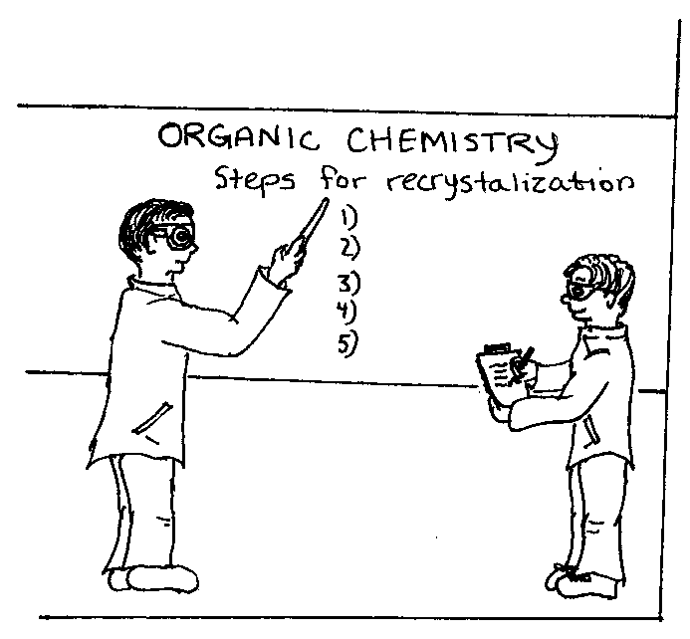
Step 2: Next we show you how to do it.

When you come to the lab, a lab instructor will
give a safety orientation, followed by a series
of mini lab lectures on each experiment.
Various techniques will be demonstrated and
you will be shown how to handle chemicals,
dispose of hazardous waste, and operate the
equipment.

Step 3: Lab Time: Now you do what you've read, been told, and shown.

This is the time you spend in the lab performing your experiments, making your products, and recording your results in this report workbook


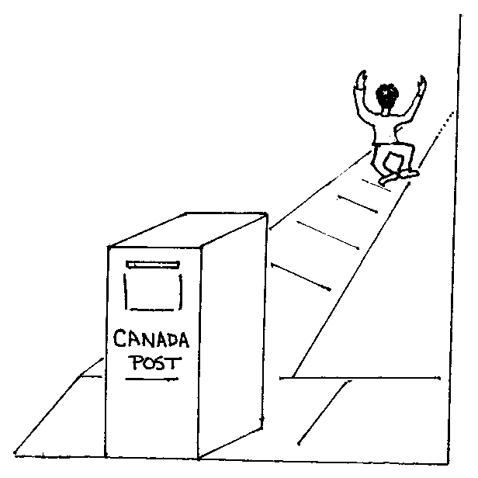
Step 4: Finally, you tell us what you did.

This is the report writing stage. Actually most of your reports will have been written while in the lab. At home you will only have to do your calculations, write your discussion and conclusion and answer the questions at the end of each experiment.

Report Book Structure and How to Prepare for the Labs:

This CHEM360 Report Book is to be used in conjunction with the CHEM360 Organic Chemistry II Lab Manual. It consists of an Introduction, Experiment Report Forms, Table of Reagents and Unknown Spectra. The reports are to be completed one month after of the lab session you attended. As a safety precaution, it is advisable to photocopy your reports before mailing them to your tutor for marking. Note: the marked reports are not returned to you.

How to best do the Report Book Exercises

1. First read through the lab manual introduction, and then answer the pre-lab questions for each experiment.
2. Complete the Objectives in the Experiment Report.
3. Complete the Procedure (Refer to lab manual pages) and make a flowchart if necessary.
4. Complete the Table of Reagents for each experiment (detach a copy of the TOR to avoid flipping back and forth)
5. You are now ready to come to the lab and do the experimental work.

Note: Each experiment in the report book has the following headings:

Report Book Heading | Purpose and Use
1. Experiment Prelab Questions | Answer these questions to help you prepare and understand what you are doing in the lab. In order to answer these questions you will have to consult the CHEM360 Lab Manual, and to read the 'Introduction to Concept', and 'Background Information' sections of this manual.  To get feedback, you may submit them to the lab coordinator before the lab session begins.*
2. Objectives | Lists what you should learn from the lab. (see also lab manual). Use this information to fill in 'Objectives' in your Lab Write-up. When appropriate, write out any chemical reactions.
3. Introduction | Briefly state how the objectives of the experiment will be achieved and provide the relevant background information.
4. Procedure | Refer to the lab manual and only note any modifications or changes. Fill out the Table of Reagents**. Use the flowchart or procedural step table to record your work and observations. No need to do it both ways.
The sections of your report shown below are completed while doing the experiment, or at home after the lab session.
5. Results | While doing or immediately after your experiment, record your results in this section of the report.
6. Discussion and Conclusion | As soon after the lab as possible, discuss your results in light of the objectives, and make the appropriate conclusions. Remember to discuss sources of potential error and loss.
7. Post Lab Questions | Answer these questions to prove you understand what you did in the lab. To be completed after the experiment is finished. Submit your answers by mail along with the Course Evaluation.
*CHEM360 Prelab questions will soon be available online at: http://science.pc.athabascau.ca/chem360.nsf
**CHEM360 Reagents is available online at: http://science.pc.athabascau.ca/chem360.nsf
Acknowledgements:

The authors wish to especially thank Ms. Aimee Caouette for all the artwork. Athabasca University also wishes to thank Drs. K. Tanabe and T. Tamura and for their permission to use the IR and 1H-NMR Spectra used in our Lab Manual and Report Book (pp. 15, 35, 46, 60, and 73). They were obtained from the SDBS web site: http://www.aist.go.jp/RIODB/SDBS/.

Each experiment in CHEM360 has been modified and rewritten from other sources, keeping the particular needs of Athabasca University students in mind. The format of this Report Book have been checked in our Athabasca laboratories by Dr. Lawton Shaw, Klaus Thomson, Nyron Jaleel, and Robert Carmichael. Special thanks to Ms. Aimee Caouette for her help on the Infrared Tutorial (Summer 1999). Also thanks to Mr. Douglas Woudstra and Mr. James Taylor (CHEM360 students 2004-05) for their helpful suggestions to improve the report book. The comments and suggestions received from all the individuals mentioned above were greatly appreciated by the Course Co-ordinator.

The following sources are also hereby acknowledged:

L.M. Browne, 2005. Laboratory Report Book, Chemistry 161, University of Alberta.
L.M. Browne, 2005. Laboratory Report Book, Chemistry 163, University of Alberta.

Lehman, J.W. 1999. Operation Organic Chemistry: A Problem-Solving Approach to the Laboratory Course, 3rd ed., Prentice Hall, New Jersey.

Mayo, D.W., R.M. Pike, and S.S. Butcher. 1989. Microscale Organic Laboratory, 2nd ed., John Wiley and Sons, Toronto, pp.229-232.

McMurry, J., 1992. Organic Chemistry, 3rd ed., Brooks/Cole Publishing Company, Pacific Grove, CA.

Weast, R.C. et al, 1974. CRC Handbook of Chemistry and Physics, 65th ed., CRC Press, Inc., Boca Raton, FL.

CHEM360 Experiment 10 Report Date:___________

Student Name:___________________ ID Number:___________

Experiment 10 Prelab Questions:

Lab Safety
- What are the hazards of working with concentrated acids like glacial acetic acid and sulfuric acid?
  - They are both extremely flammable
  - They are only mildly corrosive and no significant precautions are needed
  - Boiling these highly corrosive acids increases the danger to the experimenter, especially if the reaction flask should crack and break during heating

Equipment Preparation
- Why must the condenser be ‘clean and dry’ prior to use?
  - Clean and dry glassware automatically guarantees a higher yield
  - Water is a by-product of the reaction and having ‘wet glassware’ will slow the reaction down
  - Chemists are just neat

3. The following diagram for the ‘reflux apparatus’ used in Experiment 10 is correctly labelled.
- True
- false
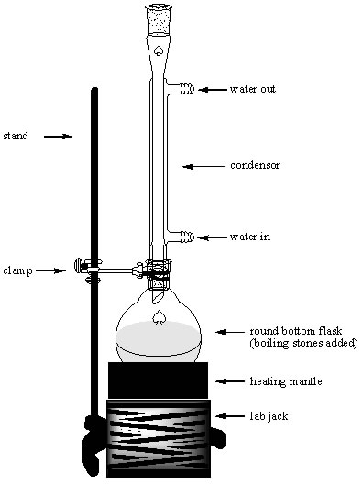

Reagent Preparation
- What are the two starting reagents used in a Fisher Esterification?
- carboxylic acid and a ketone
- alcohol and an ester
- alcohol and a carboxylic acid
- carboxylic acid and an ester

Reaction
- Is the Fisher esterification reaction reversible?
- yes
- no

- How long must you ‘reflux the reaction’ in order to maximize the amount of product formed?
- 20 min.
- 20-40 min.
- 60 min. or more (The longer the better!)

- What acts as the nucleophile (Nu), and what acts as the electrophile (E) in this reaction?
- Nu = sulphuric acid, E = acetic acid
- Nu = isoamyl alcohol, E = acetic acid (protonated form)
- Nu = isoamyl alcohol, E = acetic acid
- Nu = acetic acid, E = isoamyl acetate

Reaction Workup
- What gas is evolved during the reaction workup phase, when you wash the crude ester with 5% Na₂CO₃ (Procedure step C-5)?
- H_{2 (g)}
- N_{2 (g)}
- O_{2 (g)}
- CO_{2 (g)}

Product Characterization
- How is the ester product purified and characterized?
- Yield, refractive index, % yield, infrared spectral analysis
- Boiling point, refractive index, and infrared spectral analysis
- Yield, boiling point, refractive index, % yield, and infrared spectral analysis

- What major differences in absorption bands would you expect to see in the infrared spectra of isoamyl alcohol, and isoamyl acetate, the ester product?
- Broad 3300 cm⁻¹ absorption for alcohol, sharp ~1740 cm⁻¹ C=O of carbonyl in the ester
- Sharp ~2900 cm⁻¹ absorption(s) for sp³ C-H, no ~2900 cm⁻¹ absorption for sp³ C-H in ester.
- Sharp 3300 cm⁻¹ absorption for alcohol, broad ~1740 cm⁻¹ C=O of carbonyl in the ester .
- Sharp ~1200 cm⁻¹ absorption for C-O of alcohol, none for the ester
CHEM360 Experiment 10 Report Date:___________

Student Name:___________________ ID Number:___________

Title:

Objective(s):

Equation(s): (General and specific reaction, draw structures, and provide names)

Introduction:
Procedure: (Reference: use proper format. Any Changes/Modifications?)

Procedure for the Fisher esterification of acetic acid with isoamyl alcohol.
Procedural Step | Observations/Comments/Inferences
Record amounts of reagents used.

Table 10.1 Table of Reagents for Experiment 10 Fisher Esterification.
Reagent | Formula | Mwt.  (g/mol) | d  (g/ml) | Mp*  (°C) | Bp*  (°C) | Haz. Properties
Acetic acid, glacial (conc.)
17.4 M
Isoamyl alcohol  (3-methyl -1-butanol) | (CH₃)₂CH(CH₂)₂OH | 88.15 |  |  | 130 | Irritant
Sulfuric acid, conc.  18 M | H₂SO₄ |  | 1.840
Distilled water | H₂O | 18.02 | 1.000 | 0 | 100 | none
Diethyl ether

5% sodium carbonate (aq) | Na₂CO_{3 (aq)}
Sat. sodium chloride (aq)  (brine) | NaCl _{(aq)}
Calcium chloride (anhydr) | CaCl₂
acetone, wash

Isoamyl acetate | CH₃CO₂C₅H₁₁ | 130.19 |  |  | 142
*find and record either the melting point if the reagent is a solid at room temperature, or the boiling point if the reagent is a liquid at room temperature.
EXPERIMENT 10 FLOW CHART

REAGENT PROCEDURE / STEP OBSERVATION

Add boiling stones
Reflux for 45-60 min
Cool, transfer to sep. fun.
Add dH₂O
Amt = ______
Add diethyl ether
(ester extract’n)
Add dH₂O wash
Amt = ______
5% Na₂CO₃ wash
Check pH.
Brine wash
Amt = ______
Add drying agent
CaCl₂ (anhydr.)
Product Characterization by: ________________
Amt = _______
Amt = _______
Amt = _______
Amt = ____
Amt = ____
Distil Crude Ester
(add boiling stones)

Experiment 10 Results:

Table 10.2. Summary Table of Observations (this table is optional. Use only to tidy up observations if necessary from the previous pages. Otherwise just say “see previous pages 9-10.”):

Procedural Step | Comment or Observation and Inference

Table 10.3. Table of Product Data for Isoamyl acetate, Fisher Esterification Product.

Table 10.3. presents the summary of the results of the experiment. The calculations for limiting reagent, theoretical yield and percent yield are shown below the table. Note: _________________ was found to be the limiting reagent.
 | Yield Mass  (g) | Appearance of Liquid | Boiling Pt.*  (°C) | Refractive  Index  n_{D} obs. | Refractive  Index^  (n_{D}²⁰) | Theoretical Yield  (g) | % Yield

Isoamyl acetate

*Corrected for barometric pressure effects using the formula…
^Corrected to 20°C using the formula:

Limiting Reagent and Theoretical Yield Calculation:

Moles of acetic acid used in the reaction =

Moles of isoamyl alcohol used in the reaction =

Theoretical Yield of iosamyl acetate =

% Yield Calculation:

Table 10.4. Tabulation of Characteristic Infrared Absorptions for Starting regents and Product.

Table 10.4 contains the results of the Infrared Spectral Analyses for the isoamyl alcohol, acetic acid, and isoamyl acetate as obtained by thin film in a FTIR. See also attached spectra for peak numbering and identification.

Isoamyl alcohol | Peak  Code# | Wavenumber (cm⁻¹) | Peak Shape  (sharp, broad) | Peak Intensity  (strg,, med., or weak) | Functional Group  Indicated
>3000 cm⁻¹ Region
3000-2000 cm⁻¹ Region
2000-1400 cm⁻¹ Region
Fingerprint Region
Functional Groups Absent:

Acetic acid | Peak  Code# | Wavenumber (cm⁻¹) | Peak Shape  (sharp, broad) | Peak Intensity  (strg,, med., or weak) | Functional Group  Indicated
>3000 cm⁻¹ Region
3000-2000 cm⁻¹ Region
2000-1400 cm⁻¹ Region
Fingerprint Region
Functional Groups Absent:

Isoamyl acetate | Peak  Code# | Wavenumber (cm⁻¹) | Peak Shape  (sharp, broad) | Peak Intensity  (strg,, med., or weak) | Functional Group  Indicated
>3000 cm⁻¹ Region
3000-2000 cm⁻¹ Region
2000-1400 cm⁻¹ Region
Fingerprint Region
Functional Groups Absent:
Discussion:
Comments on reasons for yield (high or low), purity (high or low), sources of error, infrared spectrum results:

Conclusion:
Structure of Product

Experiment 10 Post Lab Questions:

1. If the cost of both the alcohol and carboxylic acid were prohibitive, how would you maximize the yield of your Fischer esterification product while keeping costs down?

2. Why did you wash your product with water (3X), before washing it with the solution of sodium hydrogen carbonate? What was the purpose of washing with sodium hydrogen carbonate?

3. Explain the function of the acid catalyst in a Fisher esterification reaction.

4. What would the reactants be to produce isoamyl valerate via Fischer esterification reaction?

Acetic acid (thin liquid film on KBr)
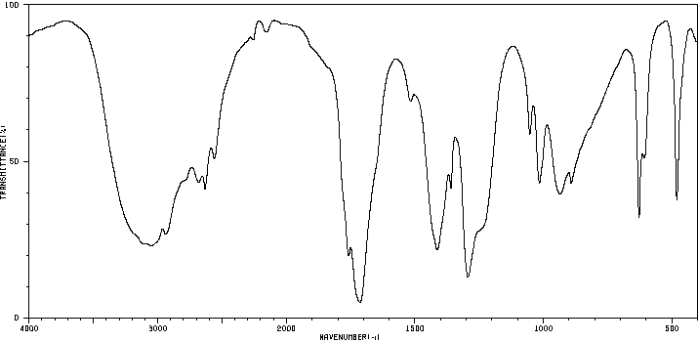
Isoamyl alcohol (thin liquid film on KBr)
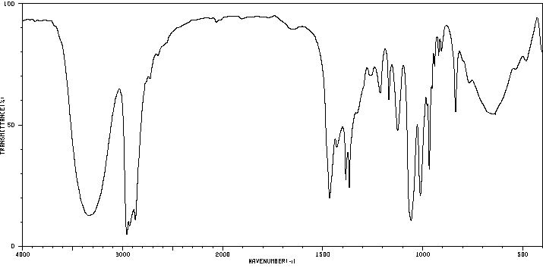
Isoamyl acetate (thin liquid film on KBr)
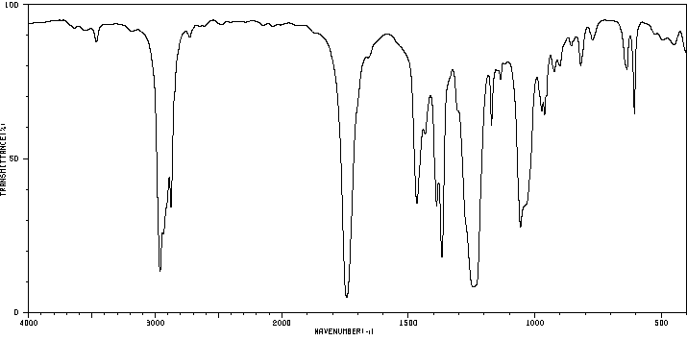

CHEM360 Experiment 11 Report Date:___________

Student Name:___________________ ID Number:___________

Experiment 11 Prelab Questions:

Lab Safety
- Should you stopper the test tubes prior to heating the tubes in the Ethanolic Silver Nitrate and Sodium Iodide/Acetone Tests?
  - Yes. You must stopper the test tubes to prevent evaporation of the test compound
  - No. You should never heat closed vessel as it may explode!
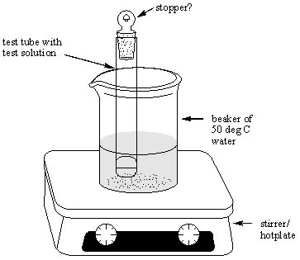

Equipment Preparation
- Should the test tubes used in this experiment be clean and dry prior to use?
- yes
- no

Reagent Preparation
- What oxidizing agent is used to detect primary and secondary alcohols, but not tertiary alcohols?
- sulphuric acid
- sodium dichromate
- mixture of sulphuric acid and sodium dichromate
- Lucas reagent

Reaction
- What is the organic product of the reaction of Lucas reagent with an alcohol?
- ketone
- silver halide
- water
- alkyl halide

- What type of alcohol would be positive in both the Dichromate and Lucas Reagent tests?
  - phenol
- primary
- secondary
- tertiary

- S_{N}1 stands for?
- substitution nucleophilic unimolecular
- substitution nucleophilic bimolecular
- substitution nucleophilic first

- S_{N}2 stands for?
- substitution nucleophilic unimolecular
- substitution nucleophilic bimolecular
- substitution nucleophilic second

- Why is the silver nitrate test a good one to observe S_{N}1 reaction mechanism behaviour?
- A positive reaction shows a change of color and is easily distinguished from a negative reaction
- precipitates that form are easily seen in positive tests
- the gas produced is easily seen in positive tests

- Why is the sodium iodide in acetone test a good one to observe S_{N}2 reaction mechanism behaviour?
- A positive reaction shows a change of color and is easily distinguished from a negative reaction
- precipitates that form are easily seen in positive tests
- the gas produced is easily seen in positive tests

Cleanup
- What should be done with the completed test solutions?
  - they should be rinsed into the Halogentated organic waste container
  - they can be rinsed down the drain
  - store them in the fumehood

CHEM360 Experiment 11 Report Date:___________

Student Name:___________________ ID Number:___________

Title:

Objective(s):

General Equation(s): (structures and names)
Procedure: (Ref:)
Changes/Modifications?

Table 11.1. Table of Reagents for Experiment 11.

Reagent | Formula | Mwt. | Vol/Mass | d | mp | bp | Haz. Properties
1-butanol | C₄H₉OH | 74.12 | 4 drops | 0.810 | -89.5 | 117-118 | Flamm., Irritant
2-butanol | C₄H₉OH | 74.12 | 4 drops | 0.807 |  | 100 | Flamm., Irritant
2-methyl-2-propanol | C₄H₉OH | 74.12 | 4 drops | 0.7887 | 25.5 | 82.3 | Flamm., Irritant
Cyclohexanol | C₆H₁₁OH | 100.16 | 4 drops | 0.9624 | 25.1 | 161.1 | Irritant, Hygroscopic
1-chlorobutane | C₄H₉Cl | 92.57 | 8 drops | 0.8862 | -123 | 78.4 | Flammable
2-chlorobutane | C₄H₉Cl | 92.57 | 8 drops | 0.8732 | -131 | 68.2 | Flammable
2-chloro-2-methylpropane | C₄H₉Cl | 92.57 | 8 drops | 0.8420 | -25.4 | 52 | Flammable
1-bromobutane | C₄H₉Br | 136.9 | 8 drops | 1.2758 | -112 | 101.6 | Flammable, Irritant
2-bromobutane | C₄H₉Br | 136.9 | 8 drops | 1.2585 | -112 | 91.2 | Flammable, Irritant
Chlorobenzene | C₆H₅Cl | 122.4 | 8 drops | 1.1058 | -45.6 | 132 | Flammable, Irritant
benzyl chloride | C₆H₅CH₂Cl | 126.59 | 8 drops | 1.1002 | -39 | 179.3 | Toxic, Cancer susp.agent
3-chloro-1-butene | C₄H₇Cl | 90.55 | 8 drops | 0.8978 |  | 64-65 | Flamm., Lachrymator
Bromocylclohexane | C₆H₁₁Br | 163.06 | 8 drops | 1.3359 | -56.5 | 166.2 | Flammable, Irritant
Bromocyclopentane | C₅H₉Br | 149.04 | 8 drops | 1.3873 |  | 136.7 | Flammable, Irritant
β-bromostyrene | C₆H₅CHCHBr | 183.05 | 8 drops | 1.4269 | 7 | 219 | Irritant
sodium dichromate | Na₂Cr₂O₇ | 261.6 | 12 mL |  |  |  | Toxic, Cancer susp.agent
sulfuric acid | H₂SO₄ | 98.08 |  |  |  |  | Corrosive, Toxic, Oxidizer
Lucas reagent | Solution of ZnCl₂ and HCl |  |  |  |  |  | Toxic, Irritant
zinc chloride, anhydrous | ZnCl₂ | 136.28 |  | 2.91 | 283 | 732 | Corrosive, Toxic
hydrochloric acid, conc. | HCl | 36.46 |  | 1.20 |  | (110) | Corrosive, Highly toxic
sodium iodide | NaI | 149.9 |  |  |  |  | Mosit. Sens., Irritant
silver nitrate | AgNO₃ | 169.8 |  |  |  |  | Highly toxic, Oxidizer
nitric acid | HNO₃ | 63.01 |  | 1.400 |  |  | Corrosive, Oxidizer
Acetone | CH₃COCH₃ | 58.09 |  | 0.818 |  | 56.5 | Flammable, Irritant
ethanol | CH₃CH₂OH | 46.07 |  | 0.785 |  | 78.5 | Flammable, Poison
Experiment 11 Part A Results: Reactions of Alcohols (1°, 2°, and 3°)

1. Alcohol Oxidation by Sodium Dichromate
Test Substance | Observation | Inference | Equation
1-butanol

2-butanol

cyclohexanol

2-methyl-2-propanol

2. Lucas Reagent Test
Test Substance | Observation | Inference | Equation
1-butanol

2-butanol

cyclohexanol

2-methyl-2-propanol

Experiment 11 Part B Results: Reactions of Alkyl Halides

Silver Nitrate Test (S_{N}1 Mechanism)
Test Substance | Observation | Inference | Equation
1-chlorobutane

2-chlorobutane

2-chloro-2-methylpropane

1-bromobutane

2-bromobutane

Chlorobenzene

Benzyl chloride

3-chloro-1-butene

Bromocyclohexane

Bromocyclopentane

β-bromostyrene

Experiment 11 Part B Results: (cont.)

Sodium Iodide/Acetone Test (S_{N}2 Mechanism)
Test Substance | Observation | Inference | Equation
1-chlorobutane

2-chlorobutane

2-chloro-2-methylpropane

1-bromobutane

2-bromobutane

Chlorobenzene

Benzyl chloride

3-chloro-1-butene

Bromocyclohexane

Bromocyclopentane

β-bromostyrene

Conclusion:

Experiment 11 Post Lab Questions:

1. There are four isomeric alcohols having the formula C₄H₁₀O, and in this experiment you investigated the properties of three of them. How would you expect the fourth isomer to behave when treated with (i) acidic sodium dichromate, and (ii) Lucas reagent?

2. On the basis of your results, arrange the eleven halogen-containing compounds in order of decreasing reactivity in (i) S_{N}1 reactions and (ii) S_{N}2 reactions.

3. a. What results would you expect to observe when benzyl alcohol, C₆H₅CH₂OH, is treated with (i) acidic sodium dichromate, and (ii) Lucas reagent?

b. What results would you expect to obtain when 1-chloro-2,2-dimethylpropane is treated with (i) ethanolic silver nitrate, and (ii) sodium iodide in acetone?

CHEM360 Experiment 12 Report Date:___________

Student Name:___________________ ID Number:___________

Experiment 12 Prelab Questions:

Lab Safety
- Sodium borohydride (NaBH₄) is much safer to use than lithium aluminium hydride (LiAlH₄)?
- yes
- no
- This statement is false. They are both safe
- This statement is false. They are both highly dangerous reagents!

Equipment Preparation
- Why must you place a magnetic stir bar into the reaction vessel and use a stir plate for this reaction?
- for the reaction to occur to its fullest extent, the reagents need to be continuously mixed
- the magnetic stir bar serves as a site for crystal nucleation
- to keep the crystalline product from settling to the bottom of the flask
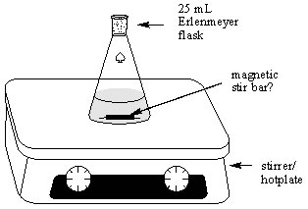

Reagent Preparation
- Why must you prepare the two main reagents, sodium borohydride and benzophenone, separately and then mix them together?
- as a safety precaution so as to avoid an uncontrolled premature reaction
- the two reagents are not miscible
- you can only do one thing at a time in a chemistry lab

Reaction
- Why do you add the sodium borohydride slowly to the benzophenone?
- to avoid spilling the reagent
- sodium borohydride is very difficult to handle
- as a safety precaution; to control the rate of the exothermic reaction

Reaction Workup
- What is the purpose of adding the hydrochloric acid/ice in the procedure step 5?
- To dilute and lower the pH of the mixture and thereby prevent product precipitation
- To decompose the excess sodium borohydride, and protonate the alcohol moiety of the final product
- To prevent the decomposition of the sodium borohydride

- Should an Erelnmeyer flask be used as the vessel to recrystallize the final product, or a beaker?
- There is no advantage. Either one could be used
- Erlenmeyer flask. The narrower neck of the Erlenmeyer flask acts like a condenser and prevents the solvent from evaporating too quickly. Also a flask can eventually be sealed with a stopper while crystal growth is occurring.
- Beaker. A beaker is easier to add solvent to and the recrystallized product is easier to recover from a beaker.

- Why is hexane used as the recrystallization solvent?
- because diphenylmethanol is soluble in hot hexane and insoluble in cold hexane
- because diphenylmethanol is insoluble in hot hexane and isoluble in cold hexane
- because it is the only solvent available

Product Characterization
- What is the purpose of performing TLC on the crude and recrystallized product, and benzophenone?
- To compare and determine the purity of the final product
- To measure the yield of the final product
- To purify the final product

- Does the TLC sketch shown here indicate the product diphenylmethanol to be pure or impure after recrystallization?
- pure
- impure
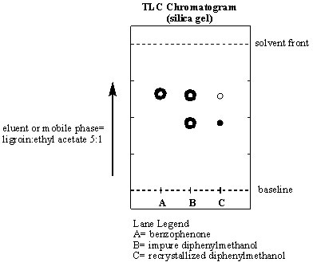

- What major differences in absorption bands would you expect to see in the infrared spectra of benzophenone, and diphenylmethanol, the alcohol product?
- sharp ~1710 cm⁻¹ C=O of carbonyl in the ketone, broad 3300 cm⁻¹ absorption for alcohol
- broad ~1740 cm⁻¹ C=O of carbonyl in the ketone, sharp 3300 cm⁻¹ absorption for alcohol
- Sharp ~1200 cm⁻¹ absorption for C-O for the ketone, not present for the alcohol
CHEM360 Experiment 12 Report Date:___________

Student Name:___________________ ID Number:___________

Title:

Objective(s):

Reaction Equation: (structures and names)

Introduction:
Procedure: (Reference format: author surname, initials, date. Title of text, publisher, pages)
Any Changes/Modifications?

Part A: Reduction of Benzophenone

Procedural Step | Observations/Comments/Inferences
Preparation of organic reagent

Preparation of reducing agent

Part B: Thin Layer Chromatography of Reagent and Product.

Procedural Step | Observations/Comments/Inferences
1. Preparation of eluent

2. Preparation of spotting solutions

3. Number of spots per lane:

4. Appearance of developed TLC

Table 12.1. Table of Reagents for Exp. 12
Reagent | Formula | Mwt. | Vol/Mass | d | moles | mp | bp | Haz. Properties
Benzophenone  (or diphenylketone) | C₆H₅COC₆H₅ | 182.22 |  | NA |  |  | NA
Sodium borohydride | NaBH₄ | 37.83 |  | NA |  | 400 | NA
Methanol | CH₃OH | 32.04 |  | 1.3288 |  | -93.9 | 65
Hydrochloric acid  (conc. = 12M) | HCl | 36.46 |  | 1.20 |  | NA
Hexane | C₆H₁₄ | 86.18 |  | 0.659 |  | NA | 69
Ethyl acetate | C₂H₅CO₂ C₂H₅ | 88.11 | 2 mL | 0.902 |  | NA | 77
Ligroin | Mineral spiritis |  | 10 mL | 0.656 |  | NA | 60-80
Chloroform | CHCl₃ | 119.39 | 3 mL | 1.500 |  | NA | 61.3
Iodine | I₂ | 253.81 | trace | NA |  | 133 | NA
Diphenylmethanol  (or benzhydrol) |  |  | ? |  |  |  | NA
NA = not applicable
SAMPLE EXPERIMENT 12 FLOW CHART

REAGENT PROCEDURE / STEP OBSERVATION

_____ g Sodium borohydride
25 mL Erlenmeyer Flask

30g ice and 3mL conc.HCl

Recrystallize

___ mL
Hexane

Product Characterization by: ________________

Experiment 12 Results:

Table 12.2. Summary Table of Observations (this table is optional. Use only to tidy up your observations from the previous page if necessary.):
Procedural Step | Comment or Observation

Table 12.3. Table of Product Data for Diphenylmethanol, the Carbonyl Reduction Product.

Table 12.3. presents the summary of the results of the experiment. The calculations for limiting reagent, theoretical yield and percent yield are shown below the table. Note: _________________ was found to be the limiting reagent.
Product Name | Yield  (Mass in g) | Appearance of Solid | Observed Melting Pt.*  (°C) | Lit. Melting Pt.  (°C) | Theoretical Yield  (g) | % Yield
*uncalibrated thermometer used.

Limiting Reagent and Theoretical Yield Calculation:

Moles of benzophenone used in the reaction =

Moles of sodium borohydride used in the reaction =

Theoretical Yield of diphenylmethanol =

% Yield Calculation:

Table 12.4. Infrared Spectrum Data Analysis (see attached spectra)

 | Absorption  Band# | Wavenumber (cm⁻¹) | Peak  Shape  (sharp, broad) | Peak Intensity  (strong, medium or weak) | Functional Group  Indicated
Functional Group absent:

 | Absorption  Band# | Wavenumber (cm⁻¹) | Peak  Shape  (sharp, broad) | Peak Intensity  (strong, medium or weak) | Functional Group  Indicated
Functional Group absent:

 | Absorption  Band# | Wavenumber (cm⁻¹) | Peak  Shape  (sharp, broad) | Peak Intensity  (strong, medium or weak) | Functional Group  Indicated
Functional Group absent:

Fig 12.1. TLC Analysis of Benzophenone, Crude and Recrystallized Diphenylmethanol

Discussion:
Comments on and reasons for yield (high/med/low), purity (high/med/low), sources of error (uncalibrated thermometer?, side reactions?):

Conclusion:
Structure of Product

Experiment 12 Post Lab Questions:

1. Aldehydes and ketones can be reduced to alcohols using hydrogen gas and a metal catalyst. Suggest two reasons why the use of sodium borohydride is preferred over the catalytic hydrogenation in order to prepare diphenylmethanol from benzophenone.

2. In this experiment, you destroyed the excess sodium borohydride by reacting it with hydrochloric acid (Part A, Step 5). What gas was evolved during the process? Write a balanced equation for the reaction that occurred. (Hint: one of the products was boric acid).

Literature Infrared Spectrum of Benzophenone (cast thin film on KBr)
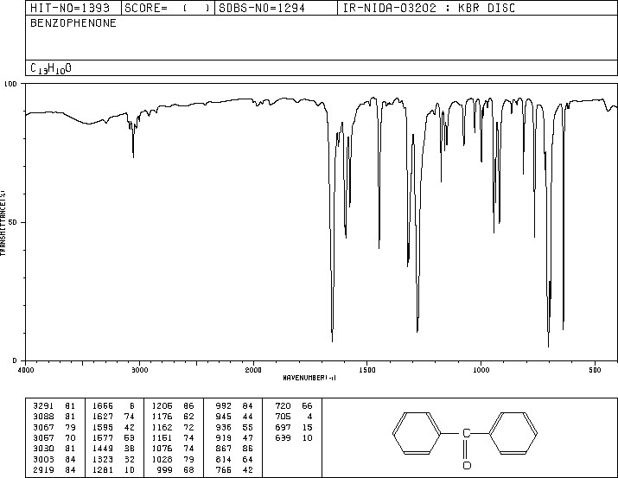

Literature Infrared Spectrum of Diphenylmethanol (cast thin film on KBr)
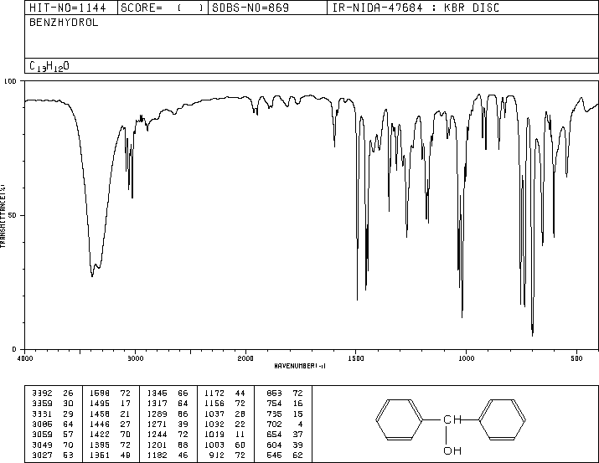
CHEM360 Experiment 13 Report Date:___________

Student Name:___________________ ID Number:___________

Experiment 13 Prelab Questions

Lab Safety
- What is the major danger of using 95% ethanol?
  - It is corrosive
  - It is flammable
  - It is an oxidizer

Equipment Preparation
- A stirrer/hot plate is used in this experiment in order to:
- continuously mix the reagents and allow the reaction to occur to its fullest extent
- the magnetic stir bar serves as a site for crystal nucleation
- to keep the crystalline product from settling to the bottom of the flask

Reagent Preparation
- How do you use the molar mass (MM, g/mol) and density (d, g/mL) of your starting aldehyde or ketone to determine the volume amount of reagent to add (mL) to the reaction, from knowing only the number of moles to use?
    - Moles reagent to use is divided by the MM = grams reagent, divided by the density = mL of reagent to use, i.e., (mol / MM)/d = mL
    - Moles reagent to use multiplied by the MM = grams reagent, divided by the density = mL of reagent to use, i.e., (mol × MM)/d = mL
    - Moles reagent to use divided by the MM = grams of reagent, multiplied by the density = mL of reagent to use, i.e., (mol /MM) × d = mL

- What is the purpose of adding the reagent 95% ethanol (in water) to the reaction mixture of the ketone and aldehyde?
- 95% ethanol is the solvent for the reaction
- 95% ethanol prevents unwanted side reactions
- 95% ethanol reacts with sodium hydroxide to form sodium ethoxide, which is the base catalyst for the reaction
Reaction
- The aldol condensation is used by synthetic chemists:
  - because it is a reversible reaction
  - because it is non-reversible reaction
  - to form a new carbon-carbon bond

Reaction Workup
- Will your product be essentially pure after cooling the flask in ice in Step 2 of the procedure?
  - yes
  - no

- Will your product be essentially pure after washing your product with ice cold 95% ethanol, ice cold 95% ethanol + 4% acetic acid and again with ice cold 95% ethanol in Step 3 of the procedure?
  - yes
  - no

- Why must the washing solutions be ice-cold in Step 3 of the procedure?
  - to prevent dissolving the product, which is more soluble in warm solvent than cold
  - to keep the reaction from warming up
  - to prevent unwanted side reactions
- How will you know which solvent (95% ethanol or toluene) is more suitable for the recrystallization of your product?
  - the chosen solvent will dissolve less crystals when hot, and form more crystals when cold
  - the chosen solvent will dissolve more crystals when hot, and form more crystals when cold
  - the chosen solvent will dissolve less crystals when hot, and form less crystals when cold

Product Characterization
- What reason(s) may help to explain a low percentage yield for your aldol condensation reaction
  - the reagents where incorrectly measured
  - all the washing steps resulted in the loss of some product, even when ice cold solvents were used
  - the chosen recrystallization solvent still kept some of the product dissolved
  - all of the above
CHEM360 Experiment 13 Report Date:___________

Student Name:___________________ ID Number:___________

Title:

Objective(s):

Reaction Equation: (structures and names)

Introduction:
Introduction: (cont.)

Procedure: (Reference: author surname, initials, date. Title of text, publisher, pages)
Any Changes/Modifications?

Mixed Aldol Condensation Reaction Observations
Procedural Step | Observations/Comments/Inferences

Table 13.1. Table of Reagents for Exp. 13
Reagent | Formula | Mwt. | d | mp | bp | Haz. Properties
Benzaldehyde |  |  | 1.044 |  | 179.5
4-methylbenzaldehyde | CH₃C₆H₄CHO |  | 1.019 |  | 204-205
4-methoxybenzaldehyde | CH₃OC₆H₄CHO |  | 1.119 |  | 248
Cinnamaldehyde | C₆H₅CH=CHCHO |  | 1.048 |  | 248
Acetone | CH₃COCH₃ |  | 0.818 |  | 56.5
Cyclopentanone | C₅H₈O |  | 0.951 |  | 130.6
Cyclohexanone | C₆H₁₀O |  | 0.947 |  | 155
4-methylcyclohexanone | CH₃C₆H₉O |  | 0.914 |  | 169-171
Ethanol | CH₃CH₂OH |  | 0.785 |  | 78.5
Sodium hydroxide | NaOH (1M) |  | ~1.00
Acetic acid | CH₃COOH |  | 1.049 |  | 118.1
Toluene | C₆H₅CH₃ |  | 0.865 |  | 110.6
Benzalacetone | C₆H₅CHCHCOCH₃
Dibenzalacetone

Dibenzalcyclohexanone

Dibenzalcyclopentanone

Chloroform | CHCl₃
Carbon tetrachloride | CCl₄
SAMPLE EXPERIMENT 13 FLOW CHART

REAGENT PROCEDURE / STEP OBSERVATION

10 mL
95% ethanol

10 mL
95%EtOH + 4% Acetic acid

10 mL
95% ethanol

Select Solvent
=______________

Product Characterization by:

Recrystallize from

Experiment 13 Results:

Table 13.2. Summary Table of Observations (this table is optional. Use only to tidy up your observations from the previous page if necessary.):
Procedural Step | Comment/Observation/Inferences

Table 13.3. Table of Data for Aldol Condensation Product.

Table 13.3 presents the summary of the results of the experiment. The calculations for limiting reagent, theoretical yield and percent yield are shown below the table. Note: Both reagents are added in equal stoichiometric amounts. The _______________________ was used as the limiting reagent as it is a 1:1 ratio with the product.

Product Name | Yield Mass  (g) | Appearance of Solid | Melting Pt.*  (°C) | Literature  Melting Pt.  (°C) | Theoretical Yield  (g) | % Yield
*Uncorrected for temperature calibration

Limiting Reagent and Theoretical Yield Calculation:

Moles of ketone actually used in the reaction =

Moles of aldehyde actually used in the reaction =

Theoretical Yield of Aldol product =

% Yield Calculation:

Table 4. Infrared Spectrum Data Analysis (see attached spectra)
Aldehyde = | Absorption  Band# | Wavenumber (cm⁻¹) | Peak  Shape  (sharp, broad) | Peak Intensity  (strong, medium or weak) | Functional Group  Indicated
Functional Group absent:

Ketone = | Absorption  Band# | Wavenumber (cm⁻¹) | Peak  Shape  (sharp, broad) | Peak Intensity  (strong, medium or weak) | Functional Group  Indicated
Functional Group absent:

Aldol Product = | Absorption  Band# | Wavenumber (cm⁻¹) | Peak  Shape  (sharp, broad) | Peak Intensity  (strong, medium or weak) | Functional Group  Indicated
Functional Group absent:

Discussion:
Comments on and give reasons for high or low yield and purity, and sources of error (practical and theoretical), etc.:

Conclusion:
Structure of Product

Experiment 13 Post Lab Questions:

1. The product obtained in this experiment results from a crossed condensation between an aldehyde and a ketone. Identify two other base-initiated reactions that could conceivably occur involving either or both of these reactants. Suggest reasons why these reactions do not result in the formation of large quantities of by-products.

2. What is the purpose of adding sodium hydroxide to the reaction mixture? (use equations if necessary to explain your answer).
Literature Infrared Spectrum of Benzaldehyde Literature Infrared Spectrum of Acetone
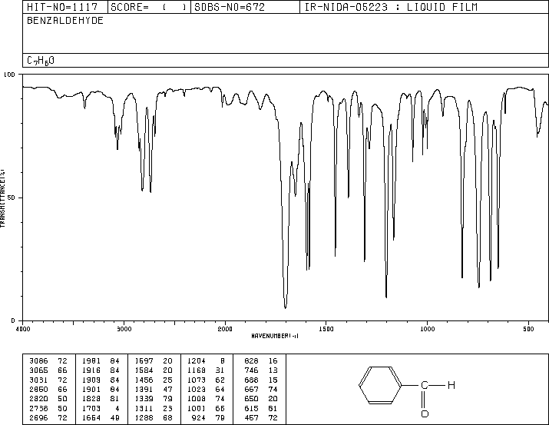
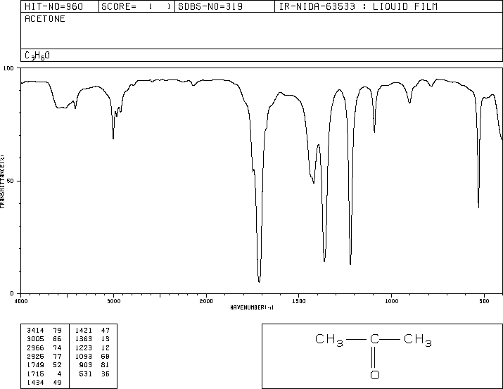

Literature Infrared Spectrum of Dibenzalacetone (cast thin film on KBr)
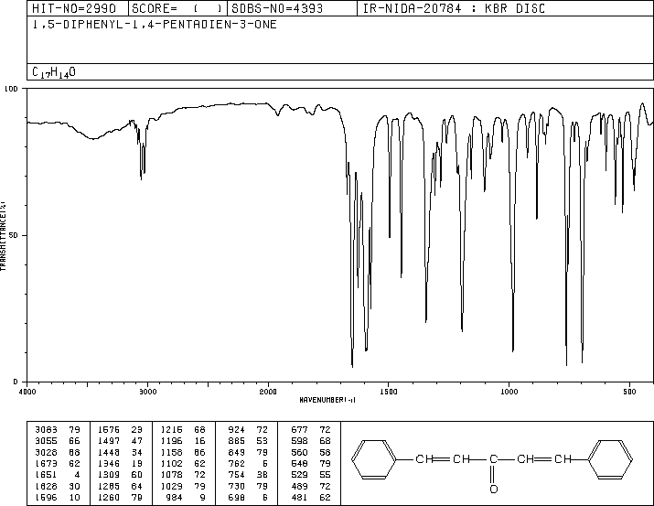

CHEM360 Experiment 14 Report Date:___________

Student Name:___________________ ID #:___________

Experiment 14 Prelab Questions:

- ¹H-NMR is an abbreviation meaning:
- nuclear magnetic resonance spectroscopy
- proton nuclear magnetic resonance spectroscopy
- carbon 13 nuclear magnetic resonance spectroscopy

- What types of information are to be found in a ¹H-NMR spectrum?
- chemical shift and multiplicity (splitting patterns)
- chemical shift, number of equivalent hydrogens, and the multiplicity
- chemical shift, number of equivalent hydrogens, multiplicity, and the number of neighbouring hydrogens
- chemical shift, number of equivalent hydrogens, multiplicity, the number of neighbouring hydrogens, and the potential signal assignment (after consulting the Shifts for Various Functional Groups table.

- If you know the chemical formula of your unknown, the ‘degrees of unsaturation’ calculation (deg Unsaturation . = nC + 1 +1/2N -1/2nH -1/2nX) helps you to:
- determine the number of ‘equivalent double bonds’ present in your unknown (e.g., alkene = 1, alkyne = 2, cylcoalkane = 1, benzene ring = 4)
- determine the functional groups present in the unknown
- determine the structure of your unknown

- Chemical shifts are the result of ‘shielding’ and ‘deshielding’ in the environment the proton finds around it.
- true
- false

5. The N=n+1 rule is used to determine the number of neighbouring H
- true
- false

6. What is the purpose of adding tetramethylsilane (TMS) to a ¹H-NMR sample prior to determining its spectrum?
  - to give an example of a highly shielded hydrogen environment
  - to serve as a reference standard
  - to serve as a blank
7. A very common splitting pattern seen in a ¹H-NMR spectrum (see Unknown X spectrum below) is the ‘2H quartet coupled to a 3H triplet’. Which of the following molecular fragments does this represent?
  - a methyl group
  - an ethyl group
  - an isopropyl group
  - a tert-butyl group

¹H-NMR spectrum for Unknown X showing a ‘2H quartet coupled to a 3H triplet’
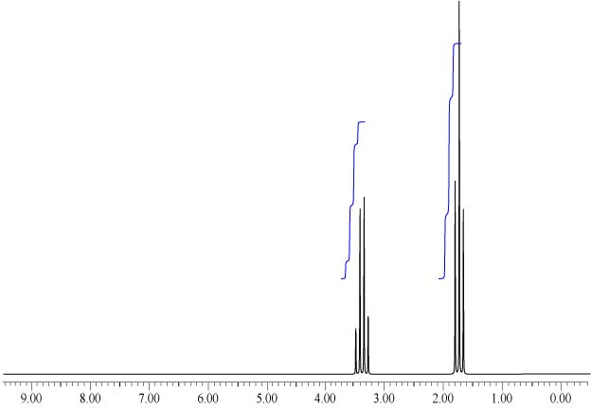

8. Another very common splitting pattern seen in a ¹H-NMR spectrum (see Unknown Y spectrum below) is a ‘1H septet coupled to a 6H doublet’. Which of the following molecular fragments does this usually represent?
    - a methyl group
    - an ethyl group
    - an isopropyl group
    - a tert-butyl group

¹H-NMR spectrum for Unknown Y showing a ‘1H septet coupled to a 6H doublet’ (ignore the singlet also shown in this example)
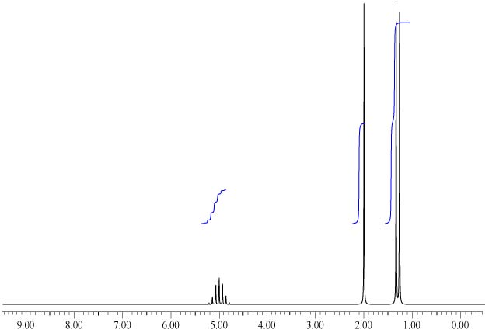

9. The following ¹H-NMR spectrum for Unknown Z shows Unknown Z to have an aromatic ring.
- true
- false

¹H-NMR spectrum for Unknown Z
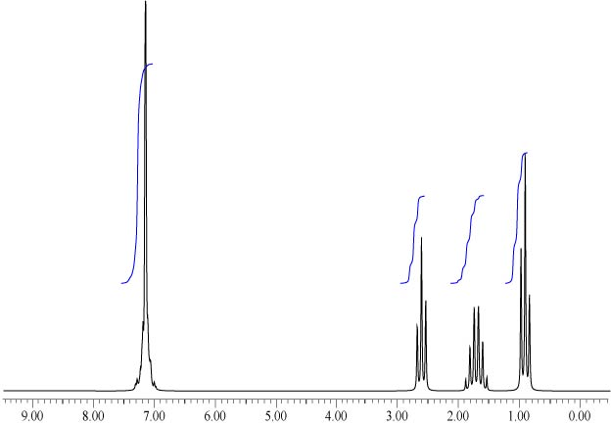

10. The hardest part in determining the structure of an unknown from your NMR data, is usually the final assembly of all the fragments.
- true
- false
CHEM360 Experiment 14 Report Date:___________

Student Name:___________________ ID Number:___________

Title:

Objective(s):

Procedure:
(Ref: )
Changes/Modification:

ATTACH YOUR 4 UNKNOWN IR/NMR SPECTRA PROBLEMS TO THIS TITLE PAGE.
The unknown spectra can be found either at the end of this Report Book or online at:
http://science.athabascau.ca/Labs/resources/360Unkns/index.php
username = auchem360 password = synthesis

CHEM360 Experiment 15 Report Date:___________

Student Name:___________________ ID Number:___________

Experiment 15 Prelab Questions

Lab Safety
- What danger exists with the Tollen’s reagent?
- The silver mirror that forms is high reflective to light
- ammonia used is very corrosive
- Tollen’s reagent decomposes on standing to an explosive substance

Equipment Preparation
- Test tube size is very important in performing functional group tests?
- true. The test tube must not become so filled with reagent and test substance, that it becomes difficult to mix
- true. The test tube must be completely filled with the reagent and test substance, so that it can only be mixed by stoppering and inverting the test tube
- false

Reagent Preparation
- What should the Tollen’s reagent appear like after the addition of the 1.0 M ammonium hydroxide?
- a brownish colored precipitate in solution
- a silver colored solution
- a clear and colorless solution

Reaction(s)
- What does the Brady’s Test detect?
- methyl ketone groups in aldehydes and ketones
- carbonyl groups of aldehydes and ketones
- aldehydes only
- ketones only

- What does the Tollens’ Test detect?
- methyl ketone groups of aldehydes and ketones
- carbonyl groups of aldehydes and ketones
- aldehydes only
- ketones only

- What does the Schiff’s Test detect?
- methyl ketone groups of aldehydes and ketones
- carbonyl groups of aldehydes and ketones
- aldehydes and aldehyde impurities mostly
- ketones only

- What does the Iodoform Test Detect?
- methyl ketone groups of aldehydes and ketones
- carbonyl groups of aldehydes and ketones
- aldehydes only
- ketones only

- Which of the following compounds gives a positive reaction to Brady’s, Tollens’, and Schiff’s Tests above?
- benzaldehyde
- cylcopentanone
- acetone

- Of the following compounds, which does not react in any of the four above tests (Brady’s, Tollens’, Schiff’s, and Iodoform Tests):
- an ethyl ketone
- cinnamaldehyde
- ethyl benzoate
- cyclohexanone

- What must be done to the unused Tollens’ reagent and any unreacted Tollens’ test samples:
- rinse the reagent into the General Organic waste container
- dilute with water
- add concentrated nitric acid to decompose the Tollens’ reagent
- leave reagent in the hood for someone else to find
CHEM360 Experiment 15 Report Date:___________

Student Name:___________________ ID Number:___________

Title:

Objective(s):

Reaction Equations:

Introduction:
Procedure:
(Ref: )
Changes/Modification:

Table 15.1. Table of Reagents for Experiment 15.
Reagent | Formula | Mwt. | d | mp | bp | Haz. Properties
Benzaldehyde | C₆H₅CHO | 106.12 | 1.044 | -26 | 179.5
4-methylbenzaldehyde | CH₃C₆H₄CHO | 120.15 | 1.019 |  | 204-205
4-methoxybenzaldehyde | CH₃OC₆H₄CHO | 136.15 | 1.119 | -1 | 248
trans-cinnamaldehyde | C₆H₅CHCHCHO | 132.16 | 1.048 |  | 248
Acetone | CH₃COCH₃ | 58.08 | 0.791 | -94 | 56
Cyclopentanone | C₅H₈ (=O) | 84.12 | 0.951 | -51 | 130-131
Cyclohexanone | C₆H₁₀ (=O) | 98.15 | 0.947 | -47 | 155
4-methylcyclohexanone | CH₃C₆H₉ (=O) | 112.17 | 0.914 |  | 169-171
Formaldehyde | HCHO | 30.03 | 1.083
Acetophenone | C₆H₅COCH₃ | 120.15 | 1.030 | 19-20 | 202
1-butanol | CH₃(CH₂)₃OH | 74.12 | 0.810 | -90 | 117.7
2-butanol | C₂H₅CH(OH)CH₃ | 74.12 | 0.807 |  | 99-100
Methanol | CH₃OH | 32.04 | 0.791 | -98 | 64.7
Brady's Reagent | Solution |  |  | See hydrazine, 2,4-dinitrophenyl
2,4-dinitrophenyl hydrazine | (O₂N)₂C₆H₃NHNH₂ | 198.14
Sulfuric acid, conc. (18 M) | H₂SO₄ | 98.08 | 1.840
Ethanol, 95% | CH₃CH₂OH | 46.07 | 0.785 |  | 78.5
Tollen's Reagent | Solution |  | See ammonia + silver nitrate
Schiff's Reagent | Solution |  | mixture of roseaniline hydrochloride and sulfur dioxide, Toxic
Ammonium hydroxide | NH₄OH | 35.05 | 0.90
Silver nitrate | AgNO₃, 0.3 M | 169.87 | 4.352 | 212
Nitric acid | HNO₃ | 63.01
Sodium hydroxide | NaOH, 3 M | 40.00 | ~1.00
Iodine in potassium iodide | I₂ in KI

Experiment 15 Part A Results:

Brady’s Test 2,4-dinitrophenylhydrazine
Test Substance | Observation | Inference | Equation
Aldehyde =

Ketone =

Positive control

Negative control

Part B Results:

Tollen’s Test - Silver Mirror
Test Substance | Observation | Inference | Equation
Aldehyde =

Ketone =

Positive control

Negative control

Part C Results:

Schiff’s Test
Test Substance | Observation | Inference | Equation
Formaldehyde

Aldehyde =

Ketone =

Iodoform Test
Test Substance | Observation | Inference | Equation
Acetone

Cyclohexanone

Acetophenone

1 butanol

2-butanol

Conclusion:
Comments on tests, sources of error, and false positives/negatives:

Experiment 15 Post Lab Questions:

1. Write a balanced equation for the reaction of acetaldehyde (i.e. ethanal) with ammoniacal silver nitrate. Remember that this is a redox reaction.

- Outline a systematic functional group test procedure that would enable you to distinguish among hexanal, 2-hexanone, 3-hexanone, 2-hexanol, and cyclohexanol.

- Aldehydes and ketones can also be easily distinguished by their infrared spectra and their identity deduced from their ¹H-NMR spectra. Explain why this is.

- From the following results, identify the unknown compounds.

a) Compound A: 2,4-DNPH positive, Tollens Test positive, Schiff's test positive, Iodoform negative (see Spectrum (A) next page).

b) Compound B: 2,4-DNPH positive, Tollens Test negative, Schiff's test negative, Iodoform positive (see Spectrum (B) next page).
Spectrum (A): ¹H-NMR, 400 MHz in CDCl₃
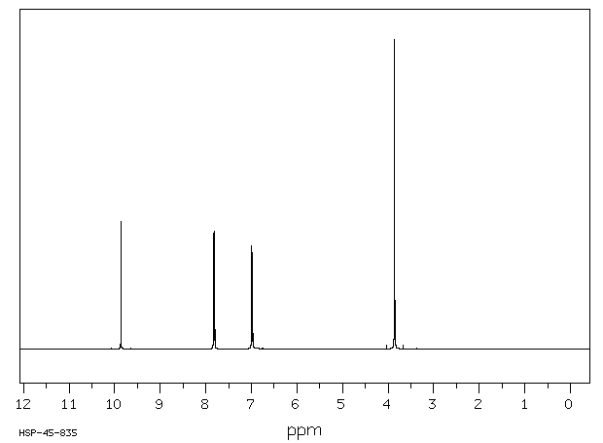Molecular Formula C₈H₈O₂ , δ 9.9 = 1H, δ 7.8 = 2H, δ 7.0 = 2H, δ 3.9 = 3H.

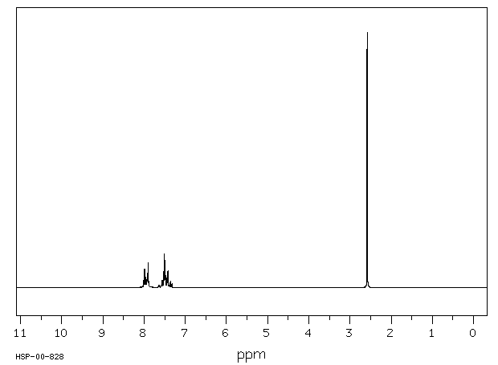Spectrum (B): ¹H-NMR, 90 MHz in CDCl₃
Molecular Formula C₈H₈O , δ 7.9 = 2H, δ 7.3-7.7 = 3H, δ 2.6 = 3H.

CHEM360 Experiment 16 Report Date:___________

Student Name:___________________ ID Number:___________

Experiment 16 Prelab Questions
Lab Safety
1. A procedureal flowchart is highly recommended for performing this experiment.
- true
- false

2. No source of flame is allowed in this experiment because of the use of diethyl ether.
- true
- false

Equipment Preparation
3. Dry glassware is essential for the Grignard reaction to work because:
- the Grignard reaction is easily contaminated with water
- the Grignard reagent is very moisture sensitive
- the Grignard reagent is very stable

Reagent Preparation
- What is the purpose of the magnesium and diethyl ether used in the Grignard Reaction?
- magnesium reacts with bromobenzene to form the alcohol product, triphenylmethanol, and diethyl ether is the solvent which keeps the product in solution
- magnesium reacts with ethyl benzoate to form the Grignard reagent, and diethyl ether is the solvent for the reaction, which also helps to stabilize the Grignard reagent
- magnesium reacts with bromobenzene to form the Grignard reagent, and diethyl ether is the solvent for the reaction, which also helps to stabilize the Grignard reagent

Reaction
- Which of the following are the limitations of the Grignard Reaction?
- the Grignard reagent is only useful in preparing tertiary alcohols, and it is moisture sensitive
- the Grignard reagent can only be formed from certain organohalides, and it is moisture, and oxygen sensitive
- the Grignard reagent can only be formed from certain organohalides, and it is oxygen sensitive

Reaction Workup
- What is the purpose of using 50mL 2M H₂SO₄ in Part C Step 1?
- To dilute and lower the pH of the mixture and thereby prevent product precipitation
- To protonate the alcohol moiety of the final product
- To prevent the decomposition of the Grignard reagent

- What layer will your product be in after addition of the diethyl ether in Part C Step 3?
- the aqueous layer
- the ether layer

- What is the purpose of washing the organic layer with water in Part C Step 6?
- to remove water soluble impurities
- to remove organic impurities
- to extract the product into the aqueous layer
- to ‘pre-dry’ the organic layer, thereby removing the bulk of the water from the ether

- What is the purpose of washing the organic layer with brine in the same Part C Step 6?
- To remove water soluble impurities
- To remove organic impurities
- To ‘pre-dry’ the organic layer, thereby removing the bulk of the water from the ether
- To remove all water from the organic layer

Product Characterization
- What is the Retention Factor or R_{f} of pure biphenyl in Lane D in the TLC sketch shown below:
- 1.54
- 0.65
- 0.154
- 0.065
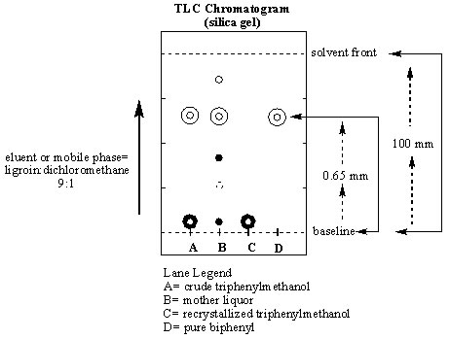
CHEM360 Experiment 16 Report Date:___________

Student Name:___________________ ID Number:___________

Title:

Objective(s):

Reaction Equation(s):

Introduction:

Procedure:
(Ref: )
Changes/Modification:

A. Procedure for formation of Grignard Reagent.

Procedural Step | Observations/Comments/Inferences

B. Procedure for the reaction of the Grignard Reagent with ethyl benzoate to form Tiphenylmethanol.

Procedural Step | Observations/Comments/Inferences

C. Procedure for isolation of Triphenylmethanol.

Procedural Step | Observations/Comments/Inferences

D. Procedure for the observation of the carbocation.

Procedural Step | Observations/Comments/Inferences

E. Procedure for assessment of product purity by Thin Layer Chromatography.

Procedural Step | Observations/Comments/Inferences

Procedure: (cont.)

Table 16.1. Table of Reagents for Experiment 16.

Reagent | Formula | Mwt. | d | mp | bp | Haz. Properties
Bromobenzene | C₆H₅Br
Magnesium |  | 24.31 | 1.75 | 649 | 1090
Ethyl benzoate | C₆H₅CO₂C₂H₅
Diethyl ether | C₂H₅OC₂H₅ | 74.12 | 0.7138 | -116 | 34.5
Sulfuric acid, 2M |  | 98.07
Sodium H carbonate |  | 84.01 | 2.159 | 270
Sodium sulfate, anhyd |  | 142.04 | 2.68
Dichloromethane |  | 84.93 | 1.325 | -95.1 | 40.1
Biphenyl | (C₆H₅)₂ | 154.21 | 0.992 | 71 | 255.9
Ligroin | (high bp pet. ether)  alkane mixt. |  | 0.656 |  | 60-80
Iodine |  | 253.8 | 4.930 | 133
Methanol | CH₃OH | 32.04 | 0.7914 | -94 | 65
Ethanol | C₂H₅OH | 46.07 | 0.7893 | -117 | 78.5
Triphenylmethanol | (C₆H₅)₃COH

SAMPLE EXPERIMENT 16 FLOW CHART Part A

REAGENT PROCEDURE / STEP OBSERVATION

Dry all glassware

___g Mg (s)

___ mL
diethyl ether

___ mol
bromobenzene

___ mL
diethyl ether

Keep warm and reflux for a further 20-30 min.

Proceed to Part B

SAMPLE EXPERIMENT 16 FLOW CHART Part B and C

REAGENT PROCEDURE / STEP OBSERVATION

Experiment 16 Results:

Table 16.2. Summary Table of Observations (this table is optional. Use only to tidy up your observations from the previous page if necessary.):
Procedural Step | Comment or Observation

Table 16.3. Table of Product Data for Triphenylmethanol, the Grignard Reaction Product.

Table 16.3. presents the summary of the results of the experiment. The calculations for limiting reagent, theoretical yield and percent yield are shown below the table. Note: _________________ was found to be the limiting reagent.
Product Name | Yield  (Mass in g) | Appearance of Solid | Observed Melting Pt.*  (°C) | Lit. Melting Pt.  (°C) | Theoretical Yield  (g) | % Yield
*uncalibrated thermometer used.

Limiting Reagent and Theoretical Yield Calculation:

Moles of magnesium used in the reaction =

Moles of bromobenzene used in the reaction =

Moles of ethyl benzoate used in the reaction =

Theoretical Yield of triphenylmethanol =

% Yield Calculation:

Fig 16.1. TLC Analysis of Biphenyl, Mother Liquor, Crude and Recrystallized Triphenylmethanol

Lane# | Dist to Center Spot ( ) | Dist to Solvent Front ( ) | Rf

Discussion:
Comments on and reasons for yield (high/med/low), purity (high/med/low), sources of error, etc.:

Structure of Product
Conclusion:

Experiment 16 Post Lab Questions:

1. How do you account for the fact that biphenyl is formed as a by-product in this reaction?

- Why do you think that reactions involving Grignard reagents are sometimes carried out in an atmosphere of nitrogen or argon?

- 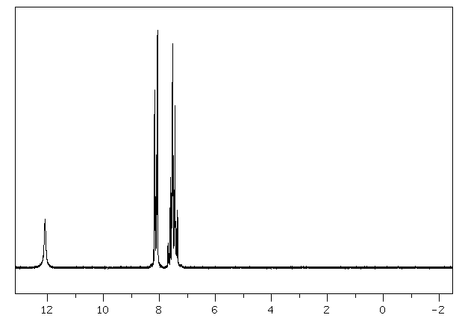A Grignard reaction was performed and the following ¹H-NMR (90 MHz in CDCl₃) was obtained of the purified product. Deduce the product's structure (Molecular Formula = C₇H₆O₂). Also write the overall reaction for its formation from any organohalide and carbonyl compound.
¹H-NMR Spectral Data:
Signal # | Shift | Integrat'n | Splitting | Comment | #Neighbour H | Signal Assignment
1 | δ 7.5 | 3H
2 | δ 8.1 | 2H
3 | δ 12.1 | 1H |  | Xchngs with D₂O

CHEM360 Experiment 17 Report Date:___________

Student Name:___________________ ID Number:___________

Experiment 17 Prelab Questions

Lab Safety
- In Part A, the reduction of 4-nitrotoluene, a dangerous gas, HCl, must be trapped using a:
- vacuum take off adaptor
- sodium hydroxide acid-vapour gas trap
- calcium chloride

Equipment Preparation
- In Part C, Step 8, the reaction mixture must be cooled in an ice bath prior to suction filtration because:
- the product is least soluble in ice cold water
- it will prevent dangerous side reactions from occuring
- it will stop the reaction between sodium hydrogen sulfite and manganese dioxide

Reagent Preparation
- In Part C, Step 3, the reason for splitting the potassium permanganate into 10 equal portions is:
- the potassium permanganate is not very soluble in hot water and therefore cannot be all added at once
- the potassium permanganate is to be carefully added in portions so as to control the rate of the oxidation reaction
- to test the student’s ability to follow procedures

Reaction
- In Part C, the oxidation of 4’-methylacetanilide, the oxidizing agent is:
- magnesium sulphate heptahydrate
- 4’methylacetanilide
- potassium permanganate
- 4-acetamidobenzoic acid

- In Part E, what is the purpose of the 100% ethanol used in Step 2.
- it is the solvent for the Fisher esterification reaction
- it is both the solvent and co-substrate for the Fisher esterification reaction
- since benzocaine is highly soluble in ethanol, it is used so that the final product will not precipitate from the reaction mixture

Reaction Workup
- In Part D, the 4-acetamidobenzoic acid is hydrolyzed by the addition of _________?
- dilute hydrochloric acid
- water
- water and 6.0 M hydrochloric acid

- In Part D, what is hydrolyzed, i.e., what is removed from the starting reagent to form the 4-aminobenzoic acid product?
- acetic acid
- ethanol
- water

- During a reflux, what constant states are maintained while the reaction proceeds? (there are 3)
- homogeneity, temperature, and volume of the solvent
- homogeneity, temperature, and volume of the starting reagent
- moles of reagent, moles of product, and temperature of the reaction

Product Characterization
- Why should you not bother to perform a melting point on 4-acetamidobenzoic acid?
- the melting point of this compound will be to low to record accurately
- the compound is very unstable and cannot be heated
- the melting point of this compound will be to high to read for the thermometers provided in this course to read
- the melting point of this compound is unknown

- If you obtained % yields of 85%, 65% and 90% in a three-step synthesis, what is the overall % yield?
- 240%
- 50%
- 145%
- 18%

CHEM360 Experiment 17 Report Date:___________

Student Name:___________________ ID Number:___________

Title:

Objective(s):

Reaction equation(s):

Introduction:
Introduction (cont.):
Procedure:
(Ref: )
Changes/Modification:

Part C. Procedure for the synthesis of 4-acetamidobenzoic acid.
Procedural Step | Observations/Comments/Inferences
Record amount/appearance of pure 4-methylacetanilide used

Reaction/Equipment Setup

Reaction

Reaction Work-up

Part D. Procedure for the synthesis of 4-aminobenzoic acid.
Procedural Step | Observations/Comments/Inferences
Record amount of pure 4-acetamidobenzoic acid used

Reaction/Equipment Setup

Reaction

Reaction Work-up

Part E. Procedure for the synthesis of benzocaine.
Procedural Step | Observations/Comments/Inferences
Record amount/appearance of pure p-aminobenzoic acid used

Reaction/Equipment Setup

Reaction

Reaction Work-up

Table 17.1. Table of Reagents for Experiment 17
Reagent | Formula | Mwt. | d | mp | bp | Haz. Properties
4-methylacetanilide

magnesium sulfate -7H₂O | MgSO₄ -7H₂O
potassium permanganate | KMnO₄
sodium hydrogen sulfite | NaHSO₃
4-acetamidobenzoic acid

hydrochloric acid | HCl
Ammonia (conc.) | NH₃
acetic acid, glacial

4-aminobenzoic acid

Ethanol

sulfuric acid | H₂SO₄
sodium carbonate | Na₂CO₃
ethyl-4-aminobenzoate

SAMPLE EXPERIMENT 17 FLOW CHART Part C

REAGENT PROCEDURE / STEP OBSERVATION

SAMPLE EXPERIMENT 17 FLOW CHART Part D

REAGENT PROCEDURE / STEP OBSERVATION

SAMPLE EXPERIMENT 17 FLOW CHART Part E

REAGENT PROCEDURE / STEP OBSERVATION

Experiment 17 Results:

Table 17.2. Table Summarizing Observations (This table is optional. Use only to tidy up your observations from the previous page if necessary.:

Procedural Step | Observations/Comments/Inferences

Table 17.3.1 Properties of the 4-methylacetanilide Oxidation Product, 4-acetamidobenzoic acid

Table 17.3.1 shows a summary of the results of the 4-acetamidobenzoic acid synthesis. The calculations for theoretical yield and percent yield are shown below the table. Note: _________________ was the limiting reagent, since the only other reagent involved in the reaction, potassium permanganate was added in excess.

Name of Product | Mass  (g) | Appearance of Solid | Melting Pt.  (°C) | Theoretical Yield (g) | % Yield

Theoretical Yield Calculation:

% Yield Calculation:

Table 17.3.2 Properties of the 4-methylacetanilide Oxidation Product, 4-aminobenzoic acid

Table 17.3.2 shows a summary of the results of the 4-aminobenzoic acid synthesis. The calculations for theoretical yield and percent yield are shown below the table. Note: ___________ was the limiting reagent, since the only other reagent involved in the reaction, phosphoric acid, served as a catalyst.

Name of Product | Mass  (g) | Appearance of Solid | Melting Pt.  (°C) | Theoretical Yield (g) | % Yield

Theoretical Yield Calculation:

% Yield Calculation:

Table 17.3.3 Properties of Fisher Esterification Product, benzocaine

Table 17.3.3 shows a summary of the results of the benzocaine synthesis. The calculations for theoretical yield and percent yield are shown below the table. Note: ___________ was the limiting reagent, since the only other reagent involved in the reaction, phosphoric acid, served as a catalyst.

 | Mass  (g) | Appearance of Solid | Melting Pt.  (°C) | Theoretical Yield (g) | % Yield

Theoretical Yield Calculation:

% Yield Calculation:

(Theoretical) Overall % Yield Calculation

Table 4.1 Tabulation of Characteristic Infrared and ¹H-NMR Absorptions for 4-acetamidobenzoic acid.

Infrared Data:
 | Absorption  Band# | Wavenumber  (cm⁻¹) | Peak Shape  (sharp, broad) | Peak Intensity  (strong, med. or weak) | Functional Group  Indicated
> 3000 cm⁻¹

Between 3000 and 2000 cm⁻¹

Between 2000 and 1400 cm⁻¹

< 1400 cm⁻¹

Functional Group(s) absent:

¹H-NMR Data:
Signal # | Shift | Integrat'n | Splitting | Comment | #Neighbour H | Signal Assignment

Table 4.2 Tabulation of Characteristic Infrared and ¹H -NMR Absorptions for 4-aminobenzoic acid.

Infrared Data:
 | Absorption  Band# | Wavenumber  (cm⁻¹) | Peak Shape  (sharp, broad) | Peak Intensity  (strong, med. or weak) | Functional Group  Indicated
> 3000 cm⁻¹

Between 3000 and 2000 cm⁻¹

Between 2000 and 1400 cm⁻¹

< 1400 cm⁻¹

Functional Group(s) absent:

¹H-NMR Data:
Signal # | Shift | Integrat'n | Splitting | Comment | #Neighbour H | Signal Assignment

Table 4.3 Tabulation of Characteristic Infrared and ¹H -NMR Absorptions for benzocaine.

Infrared Data:
 | Absorption  Band# | Wavenumber  (cm⁻¹) | Peak Shape  (sharp, broad) | Peak Intensity  (strong, med. or weak) | Functional Group  Indicated
> 3000 cm⁻¹

Between 3000 and 2000 cm⁻¹

Between 2000 and 1400 cm⁻¹

< 1400 cm⁻¹

Functional Group(s) absent:

¹H-NMR Data:
Signal # | Shift | Integrat'n | Splitting | Comment | #Neighbour H | Signal Assignment
Discussion:
Comments on and reasons for yield (high or low), purity (high/med/low), sources of error, overall synthesis effectiveness, etc.

Conclusion:
Structure of Product

Experiment 17 Post Lab Questions:

1. In Part C, what is the purpose of adding magnesium sulfate to the reaction mixture?

2. In the discussion pertaining to the hydrolysis of 4-acetamidobenzoic acid, it was argued that the presence of the electron-withdrawing carboxyl group in the para position could result in the occurrence of some nucleophilic displacement if the hydrolysis was carried out under acidic conditions and an elevated temperature. What would the product of such a nucleophilic displacement reaction?

3. Write the balanced equation for the oxidation of 4’-methylacetanilide to 4-acetamidobenzoic acid as carried out in Part C of the synthesis.

4. In Part E, what is the purpose of adding 100% ethanol to the reaction mixture? (use equations if necessary to answer this question)

Compound  Name | Chemical  Formula | Solid (S) or Liquid (L) | Formula  Weight | MP or BP  (°C) | Density  (g/mL) | Refract.  Index | Hazardous  Properties*
acetanilide | CH₃CONHC₆H₅ | S | 135.17 | 113-115 |  |  | Toxic, irritant
acetanilide,4-methyl | CH₃CONHC₆H₄CH₃ | S | 149.19 | 149-151 |  |  | Irritant
acetanilide, p-nitro | CH₃CONHC₆H₄NO₂ | S | 180.16 | 216 |  |  | Irritant
acetanilide, o-nitro | CH₃CONHC₆H₄NO₂ | S | 180.16 | 94 | 1.419 |  | Irritant
acetanilide, m-nitro | CH₃CONHC₆H₄NO₂ | S | 180.16 | 154-156 |  |  | Irritant
acetic acid, glacial (17.4 M) | CH₃CO₂H | L | 60.05 | 118.1 | 1.049 |  | Corrosive, hygroscopic
acetic acid, p-ethoxyphenyl | C₂H₅OC₆H₄CH₂CO₂H | S | 180.2 | 87-90 |  |  | Irritant
acetic anhydride | (CH₃CO)₂O | L | 102.09 | 140 | 1.082 | 1.3900 | Corrosive, lachrymator
acetone | CH₃COCH₃ | L | 58.08 | 56.5 | 0.7899 | 1.3590 | Flammable, irritant
acetone, diethylamino | (C₂H₅)₂NCH₂COCH₃ | L | 129.2 | 64/16mm | 0.832 | 1.4250 | Irritant
acetophenone | C₆H₅COCH₃ | L | 120.15 | 202 | 1.030 | 1.5325 | Irritant
activated carbon |  | S |  |  |  |  | (see charcoal)
allyl alcohol (2-propen-1-ol) | CH₂=CHCH₂OH | L | 58.08 | 96-98 | 0.854 | 1.4120 | Highly Toxic, flammable
ammonia (14.8 M) | NH₃ | L | 17.03 |  | 0.90 |  | Corrosive, lachrymator
ammonium hydroxide (14.8 M) | NH₄OH | L | 35.05 |  | 0.90 |  | Corrosive, lachrymator
aniline | C₆H₅NH₂ | L | 93.13 | 184 | 1.022 | 1.5860 | Highly toxic, irritant
aniline, 4-bromo | BrC₆H₄NH₂ | S | 172.03 | 62-64 |  |  | Toxic, irritant
aniline, 4-chloro | ClC₆H₄NH₂ | S | 127.57 | 72.5 |  |  | Highly toxic, irritant
aniline, o-ethyl | CH₃CH₂C₆H₄NH₂ | L | 121.18 | 210 |  | 1.5590 | Toxic, irritant
aniline, 2-ethoxy | CH₃CH₂OC₆H₄NH₂ | L | 137.18 | 231-233 | 1.051 | 1.5550 | Irritant, light sens.
aniline, 4-methyl | CH₃C₆H₄NH₂ | L | 107.16 | 196 | 0.989 | 1.5700 | Toxic, irritant
aniline, 3-nitro | NO₂C₆H₄NH₂ | S | 138.13 | 114 |  |  | Highly toxic, irritant
aspirin (see salicylic acid, acetate) | CH₃CO₂C₆H₄CO₂H | S | 180.16 | 138-140 |  |  | Irritant, toxic
benzaldehyde | C₆H₅CHO | L | 106.12 | 179.5 | 1.044 | 1.5450 | Hi.toxic, cancer susp.agent
benzaldehyde, 4-methyl | CH₃C₆H₄CHO | L | 120.15 | 204-205 | 1.019 | 1.5454 | Irritant (p-tolualdehyde)
benzaldehyde,4-methoxy | CH₃OC₆H₄CHO | L | 136.15 | 248 | 1.119 | 1.5730 | Irritant, (anisaldehyde)
benzaldehyde, 4-nitro | NO₂C₆H₄CHO | S | 151.12 | 106 |  |  | Irritant
benzene | C₆H₆ | L | 81.14 | 80.1 | 0.908 | 1.4990 | Flamm., cancer susp.agent
benzene, bromo | C₆H₅Br | L | 157.02 | 155-156 | 1.491 | 1.5590 | Irritant
benzene, chloro | C₆H₅Cl | L | 112.56 | 132 | 1.107 | 1.5240 | Flammable, irritant
benzoate, ethyl | C₆H₅CO₂C₂H₅ | L | 150.18 | 212.6 | 1.051 | 1.5050 | Irritant
benzoate, methyl | C₆H₅CO₂CH₃ | L | 136.15 | 198-199 | 1.094 | 1.5170 | Irritant
benzocaine,  4-aminobenzoic acid, ethyl ester, | H₂NC₆H₄CO₂C₂H₅ | S | 165.19 | 88-92 |  |  | Irritant
benzoic acid | C₆H₅CO₂H | S | 122.12 | 122.4 |  |  | Irritant
benzoic acid, 4-acetamido | CH₃CONHC₆H₄CO₂H | S | 179.18 | 256.5 |  |  | Irritant
benzoic acid, 4-amino | H₂NC₆H₄CO₂H | S | 137.14 | 188-189 | 1.374 |  | Irritant
benzoic acid, 3-chloro | ClC₆H₄CO₂H | S | 156.57 | 158 |  |  | Irritant
benzoic acid, 4-chloro | ClC₆H₄CO₂H | S | 156.57 | 243 |  |  | Irritant
benzoic acid, 3-hydroxy | HOC₆H₄CO₂H | S | 138.12 | 210-203 |  |  | Irritant
benzoic acid, 4-hydroxy | HOC₆H₄CO₂H | S | 138.12 | 215-217 |  |  | Irritant
benzoic acid, 2-methyl | CH₃C₆H₄CO₂H | S | 136.15 | 103-105 |  |  | See also o-toluic acid
benzoic acid, 4-methyl | CH₃C₆H₄CO₂H | S | 136.15 | 180-182 |  |  | See also p-toluic acid
benzoic acid, 4-nitro | O₂NC₆H₄CO₂H | S | 167.12 | 239-241 |  |  | Irritant
benzonitrile | C₆H₅CN | L | 103.12 | 191 | 1.010 | 1.5280 | Irritant
benzophenone | (C₆H₅)₂CO | S | 182.22 | 49-51 |  |  | Irritant
benzoyl chloride | C₆H₅COCl | L | 140.57 | 198 | 1.211 | 1.5530 | Corrosive, toxic
benzyl alcohol | C₆H₅CH₂OH | L | 108.14 | 205 | 1.045 | 1.5400 | Irritant, hygroscopic
benzyl amine | C₆H₅CH₂NH₂ | L | 107.16 | 184-185 | 0.981 | 1.5430 | Corrosive, lachrymator
benzyl chloride | C₆H₅CH₂Cl | L | 126.59 | 179 | 1.1002 |  | Hi.toxic, cancer susp.agent
biphenyl | C₆H₅C₆H₅ | S | 154.21 | 69-71 | 0.992 |  | Irritant
boric acid | H₃BO₃ | S | 61.83 |  | 1.435 |  | Irritant, hygroscopic
Brady’s Reagent | (NO₂)₂C₆H₃NHNH₂ | L | See hydrazine, 2,4-dinitrophenyl
bromine | Br₂ | L | 159.82 | 58.8 | 3.102 |  | Highly toxic, oxidizer
butanal | CH₃CH₂CH₂CHO | L | 72.11 | 75 |  |  | Flammable, corrosive

Compound  Name | Chemical  Formula | Solid (S) or Liquid (L) | Formula  Weight | MP or BP  (°C) | Density  (g/mL) | Refract.  Index | Hazardous  Properties*
1,3-butadiene, E,E-1,4-diphenyl | C₆H₅C₄H₄C₆H₅ | S | 206.29 | 153 |  |  | Irritant
butane, 1-bromo | CH₃CH₂CH₂CH₂Br | L | 137.03 | 101.3 | 1.276 | 1.4390 | Flammable, irritant
butane, 2-bromo | CH₃CH₂CHBrCH₃ | L | 137.03 | 91.3 | 1.255 | 1.4369 | Flammable, irritant
butane, 1-chloro | CH₃CH₂CH₂CH₂Cl | L | 92.57 | 78.4 | 0.886 | 1.4024 | Flammable liquid
butane, 2-chloro | CH₃CH₂CHClCH₃ | L | 92.57 | 68.2 | 0.873 | 1.3960 | Flammable liquid
1-butanol | CH₃CH₂CH₂CH₂OH | L | 74.12 | 117-118 | 0.810 | 1.3990 | Flammable, irritant
1-butanol, 3-methyl | (CH₃)₂CH(CH₂)₂OH | L | 88.15 | 130 | 0.8092 | 1.4053 | Irritant
2-butanol | CH₃CH₂CHOHCH₃ | L | 74.12 | 99.5-100 | 0.807 | 1.3970 | Flammable, irritant
2-butanone | CH₃CH₂COCH₃ | L | 72.11 | 80 | 0.805 | 1.3790 | Flammable, irritant
2-butanone, 3-hydroxy-3-methyl | (CH₃)₂C(OH)COCH₃ | L | 102.13 | 140-141 | 0.971 | 1.4150 | Irritant
1-butene, 3-chloro- | CH₃CH(Cl)CH=CH₂ | L | 90.55 | 62-65 | 0.900 | 1.4155 | Flammable, lachrymator
3-buten-2-ol | CH₂=CHCH(OH)CH₃ | L | 72.11 | 96-97 | 0.832 | 1.4150 | Flammable, irritant
n-butyl butyrate | C₃H₇CO₂C₄H₉ | L | 144.21 | 164-165 | 0.871 | 1.4060 | Irritant
butyric acid | CH₃(CH₂)₂CO₂H | L | 88.11 | 165.5 | 0.9577 | 1.3980 | Corrosive, toxic
3-butyn-2-ol, 2-methyl | CH≡CC(CH₃)₂OH | L | 84.12 | 104 | 0.868 | 1.4200 | Flammable, toxic
calcium carbonate | CaCO₃ | S | 100.09 |  | 2.930 |  | Irritant, hygroscopic
calcium chloride, anhydr. | CaCl₂ | S | 110.99 |  | 2.150 |  | Irritant, hygroscopic
camphor (1R, +) | C₁₀H₁₆O | S | 152.24 | 179-181 | 0.990 | 1.5462 | Flamm., irritant
carbon dioxide, solid | CO₂ | S | 44.01 | -78.5(subl.) |  |  | Frost bite burns
carbon tetrachloride | CCl₄ | L | 153.82 | 76 | 1.594 |  | Susp. Cancer agent
charcoal (Norit) |  | S | Decolourizing agent, used in recrystallizations |  |  |  | Irritant
chloroform | CHCl₃ | L | 119.38 | 61.3 | 1.500 |  | Highly toxic
cinnamaldehyde, trans | C₆H₅CH=CHCHO | L | 132.16 | 246(decomp) | 1.048 | 1.6220 | Irritant
cinnamic acid, trans | C₆H₅CH=CHCO₂H | S | 148.16 | 135-136 |  |  | Irritant
crotonaldehyde | CH₃CH=CHCHO | L | 70.09 | 102.4 | 0.846 | 1.4365 | Highly toxic, flammab.
Cyclohexane | C₆H₁₂ | L | 84.16 | 80.7 | 0.779 | 1.4260 | Flammable, irritant
cyclohexane, bromo | C₆H₁₁Br | L | 163.06 | 166.2 | 1.324 | 1.4950 | Flammable, irritant
cyclohexane, methyl | C₆H₁₁CH₃ | L | 98.19 | 101 | 0.770 | 1.4220 | Flammable, irritant
cyclohexene | C₆H₁₀ | L | 82.15 | 83 | 0.811 | 1.4460 | Flammable, irritant
cyclohexanol | C₆H₁₁OH | L | 100.16 | 161.1 | 0.963 | 1.4650 | Irritant, hygroscopic
cyclohexanone | C₆H₁₀(=O) | L | 98.15 | 155.6 | 0.947 | 1.4500 | Corrosive, toxic
cyclohexanone, 4-methyl | CH₃C₆H₉(=O) | L | 112.17 | 170 | 0.914 | 1.4460 | Corrosive, toxic
cyclopentane | C₅H₁₀ | L | 70.14 | 49.5 | 0.751 | 1.4000 | Flammable, irritant
cyclopentane, bromo | C₅H₉Br | L | 149.04 | 137-138 | 1.390 | 1.4881 | Flammable
cyclopentanone | C₅H₈(=O) | L | 84.12 | 130.6 | 0.951 | 1.4370 | Flammable, irritant
dichloromethane | CH₂Cl₂ | L | 84.93 | 40.1 | 1.325 | 1.4240 | Toxic, irritant
diethyl ether (see ethyl ether) | C₂H₅OC₂H₅ | L | 74.12 | 34.6 | 0.708 | 1.3530 | Flammable, toxic
1,4-dioxane | C₄H₈O₂ | L | 88.11 | 100-102 | 1.034 | 1.4220 | Flamm., cancer susp.agent
diphenylmethanol | (C₆H₅)₂CH(OH) | S | 184.24 | 65-67 |  |  | Irritant
ethyl acetate | CH₃CO₂C₂H₅ | L | 88.11 | 76-77 | 0.902 | 1.3720 | Flammable, irritant
ethyl alcohol, anhydrous | CH₃CH₂OH | L | 46.07 | 78.5 | 0.785 | 1.3600 | Flammable, poison
ethyl ether, absolute | CH₃CH₂OCH₂CH₃ | L | 74.12 | 34.6 | 0.708 | 1.3530 | Flammable, irritant
fluorene | C₁₃H₁₀ | S | 166.22 | 114-116 |  |  | Irritant
formaldehyde (sol’n) | HCHO | L | 30.03 | 96 | 1.083 | 1.3765 | suspect. Cancer agent
formamide, N,N-dimethyl | HCON(CH₃)₂ | L | 73.10 | 149-156 | 0.9487 | 1.4310 | suspect. Cancer agent
furfuryl amine | (C₄H₃O)CH₂NH₂ | L | 97.12 | 145-146 | 1.099 | 1.4900 | Irritant
gold | Au | S | 196.97 | 1064 | 19.28 |  | Expensive/valuable
n-hexane | CH₃(CH₂)₄CH₃ | L | 86.18 | 69 | 0.659 | 1.3750 | Flammable, irritant
hydrazine, 2,4-dinitrophenyl | (NO₂)₂C₆H₃NHNH₂ | 70% soln | 198.14 |  |  |  | Flammable, irritant
hexanes | C₆H₁₄ | L | 86.18 | 68-70 | 0.672 | 1.3790 | Flammable, irritant
hydrochloric acid, conc. 12 M | HCl | L | 36.46 |  | 1.20 |  | Corrosive, highly toxic

Compound  Name | Chemical  Formula | Solid (S) or Liquid (L) | Formula  Weight | MP or BP  (°C) | Density  (g/mL) | Refract.  Index | Hazardous  Properties*
iodine | I₂ | S | 253.81 | 133 | 4.930 |  | Corrosive, highly toxic
isoamyl acetate (isopentyl acetate) | CH₃CO₂C₅H₁₁ | L | 130.19 | 142 | 0.8670 | 1.4000 | Flammable, irritant
isoamyl alcohol | (CH₃)₂CH(CH₂)₂OH | L |  |  |  |  | (see 1-butanol, 3-methyl-)
isopentyl alcohol | (CH₃)₂CH(CH₂)₂OH | L |  |  |  |  | (see 1-butanol, 3-methyl-)
lichen |  | S |  |  |  |  | Allergin
ligroin (high bp petrol. Ether) | C₆-C₇ (light naphtha) | L |  | 60-80 | 0.656 | 1.3760 | Flammable, irritant
Lucas Reagent |  | Solution of hydrochloric acid/zinc chloride (from zinc dust) |  |  |  |  | Toxic, irritant
magnesium (metal) | Mg | S | 24.31 | 651 | 1.75 |  | Flammable
magnesium oxide | MgO | S | 40.31 |  | 3.58 |  | Moist. Sens., irritant
magnesium sulfate, anhydrous | MgSO₄ | S | 120.37 |  | 2.660 |  | Hygroscopic
magnesium sulfate, 7-hydrate | MgSO₄.7H₂O | S | 246.48 |  | 1.670 |  | (psom salt)
manganese dioxide | MnO₂ | S | 86.94 | 535 (dec.) | 5.026 |  | Oxidizer, irritant
methanol, anhyd. | CH₃OH | L | 32.04 | 64.5 | 0.791 | 1.3290 | High. Toxic, flammable
methanol, diphenyl | (C₆H₅)₂CH(OH) | S | 184.24 | 69 |  |  | Irritant
methanol, triphenyl | (C₆H₅)₃C(OH) | S | 260.34 | 164.3 |  |  | Irritant
methylene chloride | CH₂Cl₂ | L | 84.93 | 40.1 | 1.325 | 1.4230 | See dichlormethane
mineral spirits (light kerosene) | C₁₂-C₁₄ | L |  | 179-210 | 0.752 | 1.4240 | Flammable, irritant
naphthalene | C₁₀H₈ | S | 128.17 | 80.5 |  |  | Flamm., susp.cancer agent
nitric acid (conc. 15.4 M) | HNO₃ | L | 63.01 |  | 1.400 |  | Corrosive, oxidizer
2-octanone | CH₃(CH₂)₅COCH₃ | L | 128.22 | 173 | 0.819 | 1.4150 | Irritant
pentane | C₅H₁₂ | L | 72.15 | 36.1 | 0.626 | 1.3580 | Flammable, irritant
3-pentanol | C₂H₅CH(OH)C₂H₅ | L | 88.15 | 115/749mm | 0.815 | 1.4100 | Flammable, irritant
3-penten-2-one, 4-methyl | (CH₃)₂C=CHCOCH₃ | L | 98.15 | 129 | 0.858 | 1.4450 | Flammable, lachrymator
petroleum ether, (Skelly B) | Mixt. Of C₅-C₆ | L |  | 35-60 | 0.640 |  | Flammable, toxic
petroleum ether, hi bp (ligroin) | Mixt. Of C₆-C₇ | L |  | 60-80 | 0.656 | 1.3760 | Flammable, toxic
phenethyl alcohol | C₆H₅CH₂CH₂OH | L | 122.17 | 221/750mm | 1.023 | 1.5320 | Toxic, irritant
phenol | C₆H₅OH | S | 94.11 | 40-42 | 1.071 |  | Highly toxic, corrosive
phenol, 2,4-dimethyl | (CH₃)₂C₆H₃OH | S | 122.17 | 22-23 | 1.011 | 1.5380 | Corrosive, toxic
phenol, 2,5-dimethyl | (CH₃)₂C₆H₃OH | S | 122.17 | 75-77 | 0.971 |  | Corrosive, toxic
phenylacetylene | C₆H₅C≡CH | L | 102.14 | 142-144 | 0.930 | 1.5490 | Flamm., cancer susp.agent
phenylmagnesium bromide | C₆H₅MgBr | L | 181.33 |  | 1.134 |  | Flammable, moist.sensit.
phosphoric acid (85%, 14.7 M) | H₃PO₄ | L | 98.00 |  | 1.685 |  | Corrosive
potassium chromate | K₂CrO₄ | S | 194.20 | 968 | 2.732 |  | Canc.susp.agent, oxidizer
potassium dichromate | K₂Cr₂O₇ | S | 294.19 | 398 |  |  | Hi.toxic, canc.susp.agent
potassium hydroxide | KOH | S | 56.11 |  |  |  | Corrosive, toxic
potassium iodide | KI | S | 166.01 | 681 | 3.130 |  | Moist.sens., irritant
potassium permanganate | KMnO₄ | S | 158.04 | d<240 | 2.703 |  | Oxidizer, corrosive
propane, 2-chloro, 2-methyl | (CH₃)₃CCl | L | 92.57 | 50 | 0.851 | 1.3848 | Flammable
propane, 2-nitro | (CH₃)₂CHNO₂ | L | 89.09 | 120 | 0.992 | 1.3940 | Canc.susp.agent, flamm.
propanoic acid (or propionic acid) | CH₃CH₂CO₂H | L | 74.08 | 141 | 0.9930 | 1.3869 | Corrosive, toxic
1-propanol | CH₃CH₂CH₂OH | L | 60.11 | 97.4 | 0.8035 | 1.3850 | Flammable, irritant
1-propanol, 2-methyl- | (CH₃)₂CHCH₂OH | L | 74.12 | 108.1 | 0.8018 | 1.3955 | Flammable, irritant
2-propanol, 2-methyl- | (CH₃)₃COH | L | 74.12 | 82.3 | 0.7887 |  | Flammable, irritant
propionate, ethyl | C₂H₅CO₂C₂H₅ | L | 102.13 | 99 | 0.891 | 1.3840 | Flammable, irritant
propionic acid | C₂H₅CO₂H | L | 74.08 | 141 | 0.993 | 1.3860 | Corrosive, toxic
rosaniline hydrochloride | C₂₀H₁₄(NH₂)₃Cl | Solution | 337.86 | 250 (dec) |  |  | Susp. cancer agent
salicylic acid | HOC₆H₄CO₂H | S | 138.12 | 158-160 |  |  | Toxic, irritant
salicylic acid, acetate ester | CH₃CO₂C₆H₄CO₂H | S | 180.16 | 138-140 |  |  | Irritant, toxic
Schiff’s Reagent |  | Solution | of roseaniline hydrochloride & sulfur dioxide |  |  |  | Toxic
silane, tetramethyl | Si(CH₃)₄ | L | 88.23 | 26-28 | 0.648 | 1.3580 | Flammable, hygroscopic
silica, sand | SiO₂ | S | 60.09 | NA |  |  | abrasive
silver nitrate | AgNO₃ | S | 169.88 | 212 | 4.352 |  | Highly toxic, oxidizer
sodium acetate | CH₃CO₂Na | S | 82.03 |  |  |  | hygroscopic
sodium acetate, trihydrate | CH₃CO₂Na 3H₂O | S | 136.08 | 58 | 1.45 |  | Hygroscopic

Compound  Name | Chemical  Formula | Solid (S) or Liquid (L) | Formula  Weight | MP or BP  (°C) | Density  (g/mL) | Refract.  Index | Hazardous  Properties*
sodium bisulfite | NaHSO₃ | S |  |  | 1.480 |  | Severe irritant
sodium borohydride | NaBH₄ | S | 37.38 | 400 |  |  | Flam. solid, corrosive
sodium bicarbonate | NaHCO₃ | S | 84.01 |  | 2.159 |  | Moist. sensitive
sodium carbonate | Na₂CO₃ | S | 105.99 | 851 | 2.532 |  | Irritant, hygroscopic
sodium chloride | NaCl | S | 58.44 | 801 | 2.165 |  | Irritant, hygroscopic
sodium dichromate, dihydrate | Na₂Cr₂O₇.2H₂O | S | 298.00 |  | 2.350 |  | Hi.toxic, cancer susp.agent
sodium hydrogen carbonate | NaHCO₃ | S | 84.01 |  | 2.159 |  | See sodium bicarbonate
sodium hydroxide | NaOH | S | 40.00 |  |  |  | Corrosive, toxic
sodium iodide | NaI | S | 149.89 | 661 | 3.670 |  | Moist.sens., irritant
sodium metabisulfite | Na₂S₂O₅ | S | 190.10 |  | 1.480 |  | Moist.sens., toxic
sodium methoxide | NaOCH₃ | S | 54.02 |  |  |  | Flam. solid, corrosive
sodium sulfate | Na₂SO₄ | S | 142.04 | 884 | 2.680 |  | Irritant, hygroscopic
styrene | C₆H₅CH=CH₂ | L | 104.15 | 146 | 0.909 |  | Flammable
styrene, β-bromo | C₆H₅CH=CHBr | L | 183.05 | 112/20mm | 1.427 | 1.6070 | Irritant
sucrose | C₁₂H₂₂O₁₁ | S | 342.30 | 185-187 | 1.5805 |  | Tooth Decay!
sulfur dioxide | SO₂ | Gas | 64.06 | -10 bp |  |  | Nonflamm, corrosive
sulfuric acid (conc. 18 M) | H₂SO₄ | L | 98.08 |  | 1.840 |  | Corrosive, oxidizer
sulfurous acid | H₂SO₃ | L | 82.08 |  | 1.030 |  | Corrosive, toxic
L-tartaric acid | HO₂CC₂H₂(OH)₂CO₂H | S | 150.09 | 171-174 |  |  | Irritant
tetrahydrofuran | C₄H₈O | L | 72.11 | 65-67 | 0.889 | 1.4070 | Flammable, irritant
tetramethylsilane | Si(CH₃)₄ | L | 88.23 | 26-28 | 0.648 | 1.3580 | Flammable, hygroscopic
tin | Sn | S | 118.69 |  | 7.310 |  | Flammable solid, moist.sens.
Tollen’s Reagent |  | L | See ammonia + silver nitrate
toluene | C₆H₅CH₃ | L | 92.14 | 110.6 | 0.867 | 1.4960 | Flammable, toxic
toluene, 4-nitro | NO₂C₆H₄CH₃ | S | 137.14 | 52-54 | 1.392 |  | Hi.toxic, irritant
o- or 2-toluic acid | CH₃C₆H₄CO₂H | S | 136.15 | 103-105 |  |  | Probable irritant
p- or 4-toluic acid | CH₃C₆H₄CO₂H | S | 136.15 | 180-182 |  |  | Probable irritant
triethylphosphite | (C₂H₅O)₃P | L | 166.16 | 156 | 0.969 | 1.4130 | Moist. sens., irritant
triphenylmethanol | (C₆H₅)₃C(OH) | S | 260.34 | 164.3 |  |  | Probable irritant
urea | NH₂CONH₂ | S | 60.06 | 135 | 1.335 |  | Irritant
(-) usnic acid | C₁₈H₁₆O₇ | S | 344.32 | 198 |  |  | Toxic
(+) usnic acid | C₁₈H₁₆O₇ | S | 344.32 | 201-203 |  |  | Toxic
water | H₂O | L | 18.02 | 100 |  | 1.33 | Will burn skin when hot
water, ice | H₂O | S/L | 18.02 | 0 | 1.00 |  | Frostbite, hypothermia
xylenes | CH₃C₆H₄CH₃ | L | 106.17 | 137-144 | 0.860 | 1.4970 | Flammable, irritant
zinc, dust | Zn | S | 65.37 | 419.5 |  |  | Flammable, moist.sens.
zinc chloride, anhydrous | ZnCl₂ | S | 136.28 | 283 | 2.91 |  | Corrosive, toxic
*Be sure to consult the chemical’s MSDS for more specific detail on hazardous properties.

Athabasca University
CHEM360/Labc360-Organic Chemistry II
PRELAB ANSWERS (2019-21)
http://science.pc.athabascau.ca/chem360.nsf
(Click on ‘CHEM360 Prelab Questions’ in the side menu)

Question | Exp.10 | Exp. 11 | Exp. 12 | Exp. 13 | Exp.14 | Exp. 15 | Exp. 16 | Exp. 17
1 | c | b | a | b | b | c | a | b
2 | b | a | a | a | d | a | a | a
3 | a | c | a | c | a | c | b | b
4 | c | d | c | c | a | b | c | c
5 | a | c | b | c | a | c | b | b
6 | c | a | b | b | b | c | b | c
7 | b | b | a | b | b | a | b | a
8 | d | b | a | a | c | a | a | a
9 | c | b | b | b | a | c | c | c
10 | a | a | a | d | a | c | b | b

Unknown # 360-14-1
Mol. Wt. = 89.09 g/mol Chemical Formula = C₃H₇O₂N Degrees of Unsaturation = ___________________________________
b.p. = 120°C
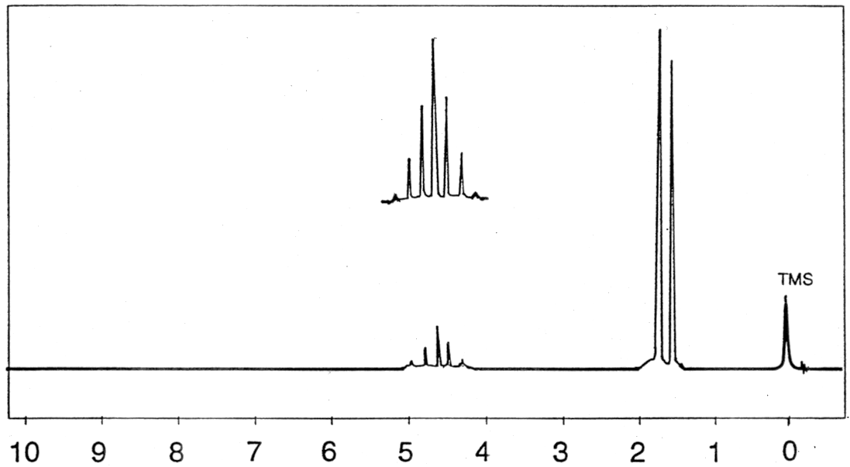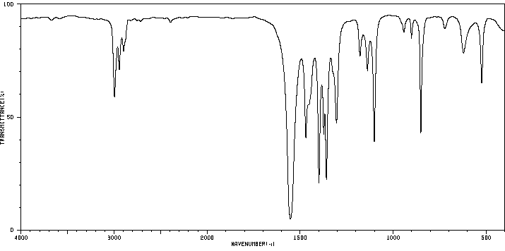Infrared Spectrum (liquid film (neat) on KBr Disc) ¹H-NMR Spectra (at 60 MHz in CDCl₃)
(PPM)

Infrared Spectrum (liquid film (neat) on KBr disc): ¹H-NMR Integration Data: (at 60 MHz in CDCl₃)
Spectrum Region | Absorp'n  Band # | Frequency  (cm⁻¹) | Peak Shape  (sharp, broad) | Peak Intensity  (strong, med. or weak) | Functional Group  Indicated | Signal # | Shift | Integrat'n | Splitting | Comment | #Neigh-bouring H | Signal Assignment
 |  |  |  |  |  | 1 | δ 1.6 | 6H
 |  |  |  |  |  | 2 | δ 4.65 | 1H
Structure Assigned to Unknown 360-14-1
Compound Name:

Unknown # 360-14-2
Mol. Wt. = 72.112 g/mol Chemical Formula = C₄H₈O Degrees of Unsaturation = ___________________________________
b.p. = 80°C
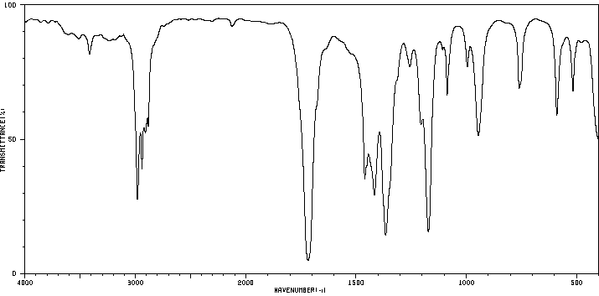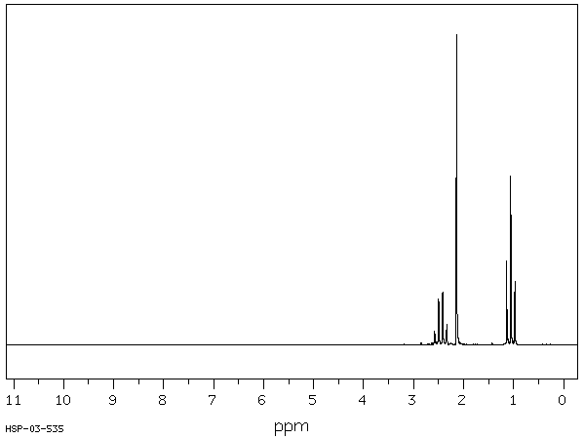IR Spectra (liquid film (neat) on KBr Disc) ¹H-NMR Spectra (at 90 MHz in CDCl₃)

Infrared Spectra (liquid film (neat) on KBr disc): ¹H-NMR Integration Data: (at 90 MHz in CDCl₃)
Spectrum Region | Absorp'n  Band # | Frequency  (cm⁻¹) | Peak Shape  (sharp, broad) | Peak Intensity  (strong, med. or weak) | Functional Group  Indicated | Signal # | Shift | Integrat'n | Splitting | Comment | #Neigh-bouring H | Signal Assignment
 |  |  |  |  |  | 1 | δ 1.1 | 3H
 |  |  |  |  |  | 2 | δ 2.1 | 3H
 |  |  |  |  |  | 3 | δ 2.45 | 2H
Structure Assigned to Unknown 360-14-2
Compound Name:
Unknown # 360-14-3
Mol. Wt. = 180.2 g/mol Chemical Formula = C₁₀H₁₂O₃ Degrees of Unsaturation = ___________________________________
m.p. = 90°C
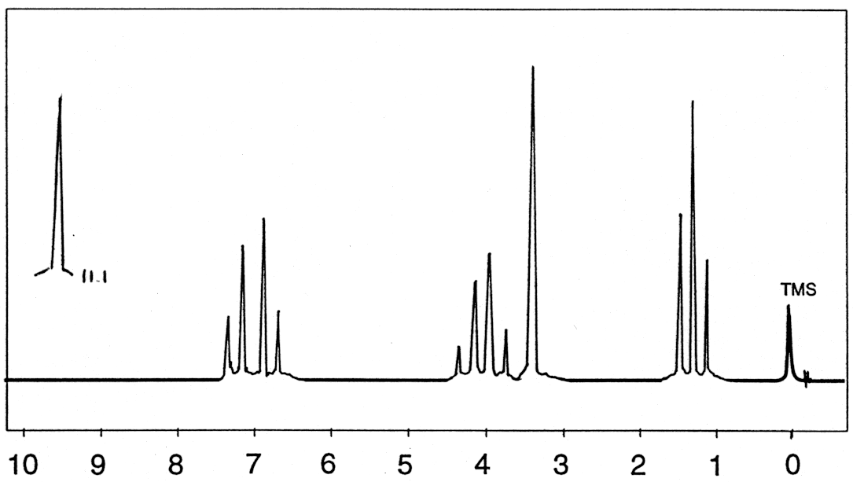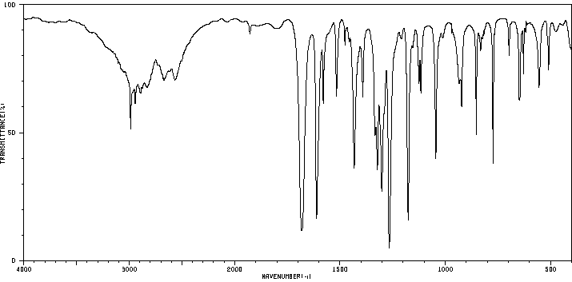Infrared Spectrum (liquid film (neat) on KBr Disc) ¹H-NMR Spectra (at 60 MHz in CDCl₃)
(PPM)
Infrared Spectrum (liquid film (neat) on KBr disc): ¹H-NMR Integration Data: (at 60 MHz in CDCl₃)
Spectrum Region | Absorp'n  Band # | Frequency  (cm⁻¹) | Peak Shape  (sharp, broad) | Peak Intensity  (strong, med. or weak) | Functional Group  Indicated | Signal # | Shift | Integrat'n | Splitting | Comment | #Neigh-bouring H | Signal Assignment
 |  |  |  |  |  | 1 | δ 1.3 | 3H
 |  |  |  |  |  | 2 | δ 3.6 | 2H
 |  |  |  |  |  | 3 | δ 4.0 | 2H
 |  |  |  |  |  | 4 | 7.0 | 4H
 |  |  |  |  |  | 5 | δ 11.1 | 1H
Structure Assigned to Unknown 360-14-3
Compound Name:
Unknown # 360-14-4
Mol. Wt. = 70.09 g/mol Chemical Formula = C₄H₆O Degrees of Unsaturation = ___________________________________
b.p. = 104°C
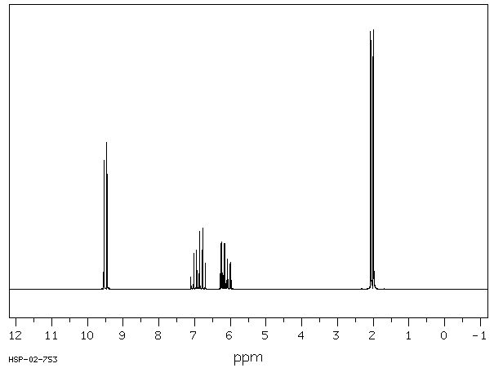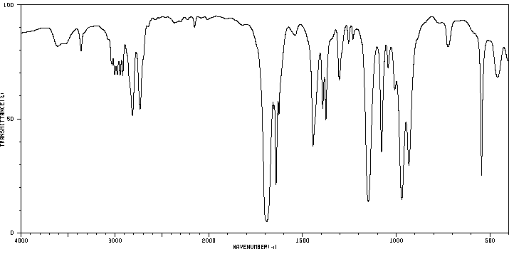IR Spectra (liquid film (neat) on KBr Disc) ¹H-NMR Spectra (at 90 MHz in CDCl₃)
Infrared Spectra (liquid film (neat) on KBr disc): ¹H-NMR Integration Data: (at 90 MHz in CDCl₃)
Spectrum Region | Absorp'n  Band # | Frequency  (cm⁻¹) | Peak Shape  (sharp, broad) | Peak Intensity  (strong, med. or weak) | Functional Group  Indicated | Signal # | Shift | Integrat'n | Splitting | Comment | #Neigh-bouring H | Signal Assignment
 |  |  |  |  |  | 1 | δ 2.0 | 3H
 |  |  |  |  |  | 2 | δ 6.15 | 1H
 |  |  |  |  |  | 3 | δ 6.9 | 1H
 |  |  |  |  |  | 4 | δ 9.5 | 1H
 |  |  |  |  |  | Hint: J(2,4)=7.8Hz, J(2,3)=15.5Hz, J(1,3)=6.8Hz, J(1,2)=1.5Hz
Structure Assigned to Unknown 360-14-4
Compound Name:
Unknown # 360-14-5
Mol. Wt. = 102.13 g/mol Chemical Formula = C₅H₁₀O₂ Degrees of Unsaturation = ___________________________________
b.p. = 141°C
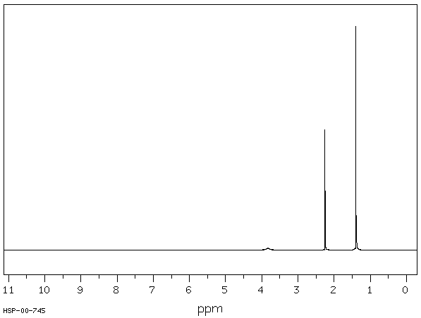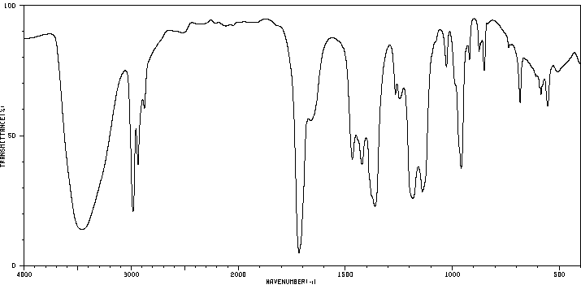 IR Spectra (liquid film (neat) on KBr Disc) ¹H-NMR Spectra (at 90 MHz in CDCl₃)
Infrared Spectra (liquid film (neat) on KBr disc): ¹H-NMR Integration Data: (at 90 MHz in CDCl₃)
Spectrum Region | Absorp'n  Band # | Frequency  (cm⁻¹) | Peak Shape  (sharp, broad) | Peak Intensity  (strong, med. or weak) | Functional Group  Indicated | Signal # | Shift | Integrat'n | Splitting | Comment | #Neigh-bouring H | Signal Assignment
 |  |  |  |  |  | 1 | δ 1.4 | 6H
 |  |  |  |  |  | 2 | δ 2.2 | 3H
 |  |  |  |  |  | 3 | δ 3.8 | 1H |  | xchanges with D₂O
Structure Assigned to Unknown 360-14-5
Compound Name:
Unknown # 360-14-6
Mol. Wt. = 104.15 g/mol Chemical Formula = C₈H₈ Degrees of Unsaturation = ___________________________________
b.p. = 146°C
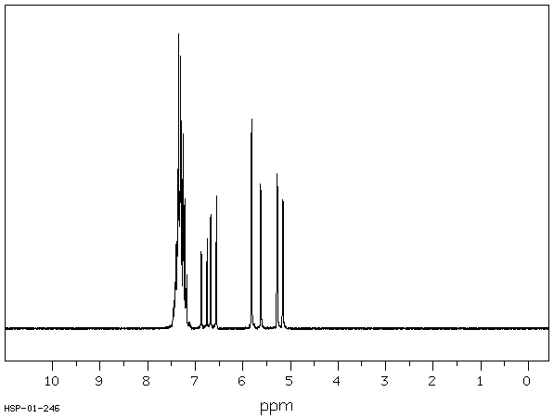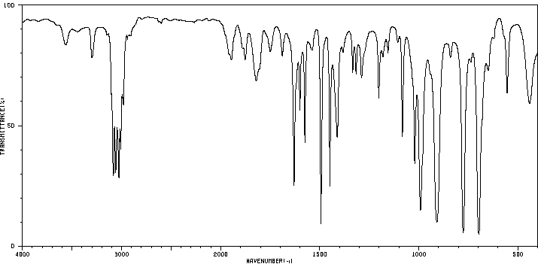 IR Spectra (liquid film (neat) on KBr Disc) ¹H-NMR Spectra (at 90 MHz in CDCl₃)
Infrared Spectra (liquid film (neat) on KBr disc): ¹H-NMR Integration Data: (at 90 MHz in CDCl₃)
Spectrum Region | Absorp'n  Band # | Frequency  (cm⁻¹) | Peak Shape  (sharp, broad) | Peak Intensity  (strong, med. or weak) | Functional Group  Indicated | Signal # | Shift | Integrat'n | Splitting | Comment | #Neigh-bouring H | Signal Assignment
 |  |  |  |  |  | 1 | δ 5.2 | 1H
 |  |  |  |  |  | 2 | δ 5.7 | 1H
 |  |  |  |  |  | 3 | δ 6.7 | 1H
 |  |  |  |  |  | 4 | δ 7.3 | 5H
Structure Assigned to Unknown 360-14-6
Compound Name:

Unknown # 360-14-7
Mol. Wt. = 121.18 g/mol Chemical Formula = C₈H₁₁N Degrees of Unsaturation = ___________________________________
b.p. = 210°C
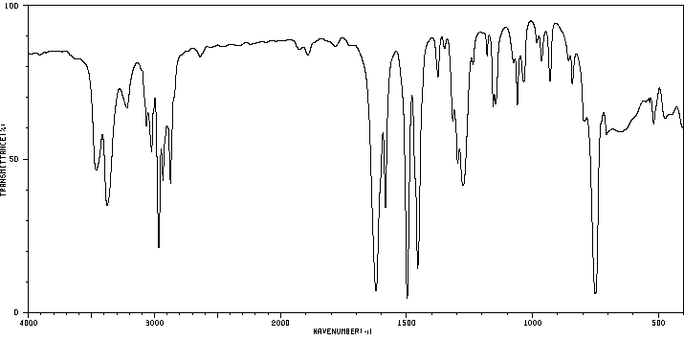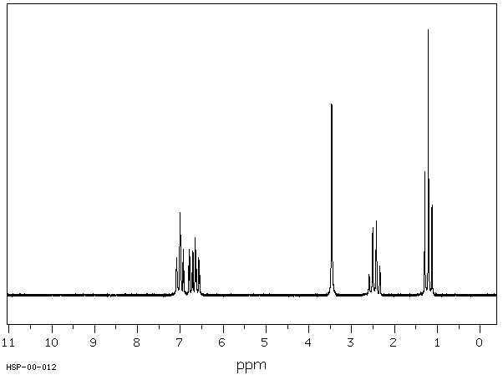 IR Spectra (liquid film (neat) on KBr Disc) ¹H-NMR Spectra (at 90 MHz 10.5 mol% in CDCl₃)
Infrared Spectra (liquid film (neat) on KBr disc): ¹H-NMR Integration Data: (at 90 MHz 10.5 mol% in CDCl₃)
Spectrum Region | Absorp'n  Band # | Frequency  (cm⁻¹) | Peak Shape  (sharp, broad) | Peak Intensity  (strong, med. or weak) | Functional Group  Indicated | Signal # | Shift | Integrat'n | Splitting | Comment | #Neigh-bouring H | Signal Assignment
 |  |  |  |  |  | 1 | δ 1.2 | 3H
 |  |  |  |  |  | 2 | δ 2.46 | 2H
 |  |  |  |  |  | 3 | δ 3.47 | 2H |  | xchanges with D₂O
 |  |  |  |  |  | 4 | δ 6.65 | 2H
 |  |  |  |  |  | 5 | δ 7.0 | 2H
Structure Assigned to Unknown 360-14-7
Compound Name:

Unknown # 360-14-8
Mol. Wt. = 129.2 g/mol Chemical Formula = C₇H₁₅NO Degrees of Unsaturation = ___________________________________
m.p. = 64°C (16mm)
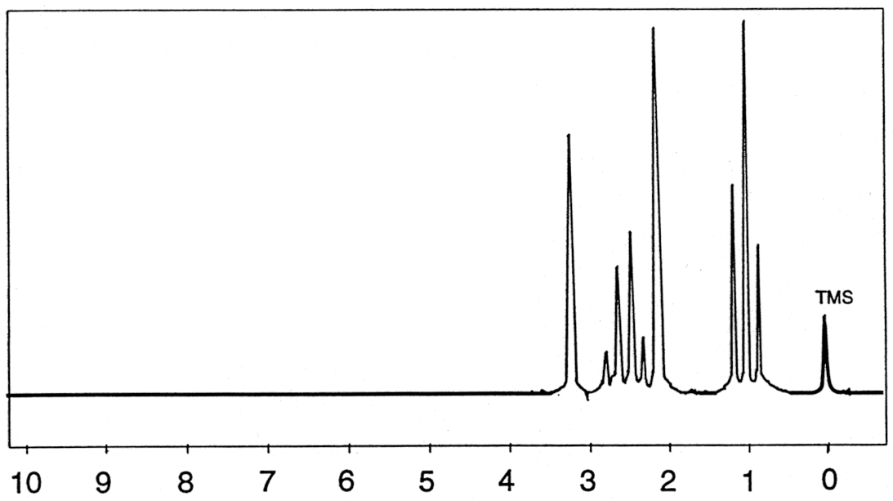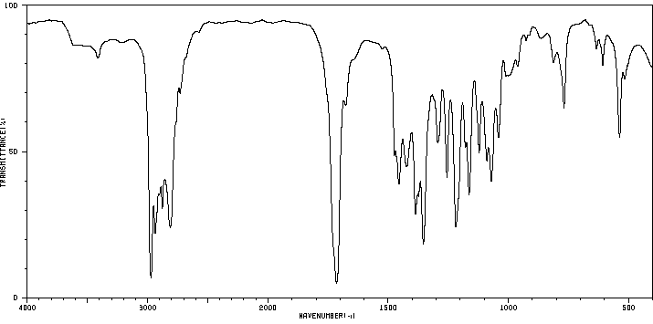Infrared Spectrum (liquid film (neat) on KBr Disc) ¹H-NMR Spectra (at 60 MHz in CDCl₃)
(PPM)
Infrared Spectrum (liquid film (neat) on KBr disc): ¹H-NMR Integration Data: (at 60 MHz in CDCl₃)
Spectrum Region | Absorp'n  Band # | Frequency  (cm⁻¹) | Peak Shape  (sharp, broad) | Peak Intensity  (strong, med. or weak) | Functional Group  Indicated | Signal # | Shift | Integrat'n | Splitting | Comment | #Neigh-bouring H | Signal Assignment
 |  |  |  |  |  | 1 | δ 1.0 | 6H
 |  |  |  |  |  | 2 | δ 2.10 | 3H
 |  |  |  |  |  | 3 | δ 2.55 | 4H
 |  |  |  |  |  | 4 | δ 3.25 | 2H
Structure Assigned to Unknown 360-14-8
Compound Name:

Unknown # 360-14-9
Mol. Wt. = 152.15 g/mol Chemical Formula = C₈H₈O₃ Degrees of Unsaturation = ___________________________________
m.p. = 182-185°C
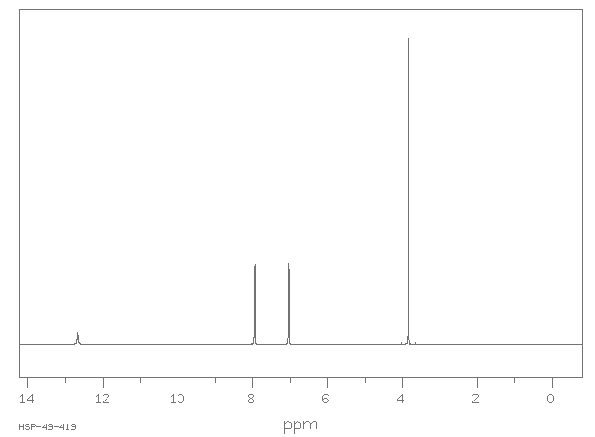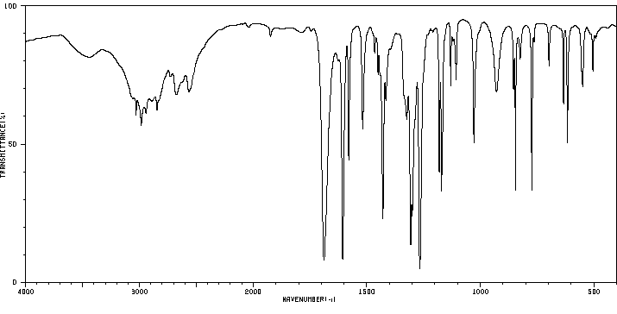 IR Spectra (on KBr Disc) ¹H-NMR Spectra (at 400 MHz in DMSO-d₆)
Infrared Spectra (on KBr disc): ¹H-NMR Integration Data: (at 400 MHz in DMSO-d₆)
Spectrum Region | Absorp'n  Band # | Frequency  (cm⁻¹) | Peak Shape  (sharp, broad) | Peak Intensity  (strong, med. or weak) | Functional Group  Indicated | Signal # | Shift | Integrat'n | Splitting | Comment | #Neigh-bouring H | Signal Assignment
 |  |  |  |  |  | 1 | δ 3.8 | 3H
 |  |  |  |  |  | 2 | δ 7.0 | 2H
 |  |  |  |  |  | 3 | δ 7.9 | 2H
 |  |  |  |  |  | 4 | δ 12.7 | 1H
Structure Assigned to Unknown 360-14-9
Compound Name:

Unknown # 360-14-10
Mol. Wt. = 102.13 g/mol Chemical Formula = C₅H₁₀O₂ Degrees of Unsaturation = ___________________________________
b.p. = 99°C
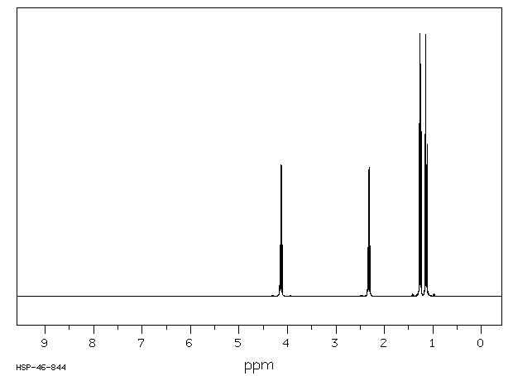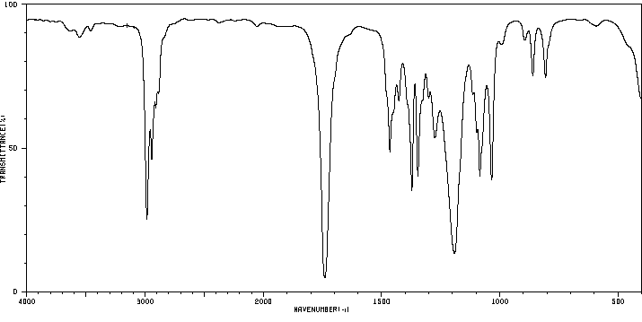 IR Spectra (thin film (neat) on KBr Disc) ¹H-NMR Spectra (at 400 MHz in CDCl₃)
Infrared Spectra (thin film (neat) on KBr disc): ¹H-NMR Integration Data: (at 400 MHz in CDCl₃)
Spectrum Region | Absorp'n  Band # | Frequency  (cm⁻¹) | Peak Shape  (sharp, broad) | Peak Intensity  (strong, med. or weak) | Functional Group  Indicated | Signal # | Shift | Integrat'n | Splitting | Comment | #Neigh-bouring H | Signal Assignment
 |  |  |  |  |  | 1 | δ 1.1 | 3H
 |  |  |  |  |  | 2 | δ 1.3 | 3H
 |  |  |  |  |  | 3 | δ 2.3 | 2H
 |  |  |  |  |  | 4 | δ 4.2 | 2H
Structure Assigned to Unknown 360-14-10
Compound Name:

Unknown # 360-14-11
Mol. Wt. = 74.1 g/mol Chemical Formula = C₄H₁₀O Degrees of Unsaturation = ___________________________________
b.p. = 117.7°C
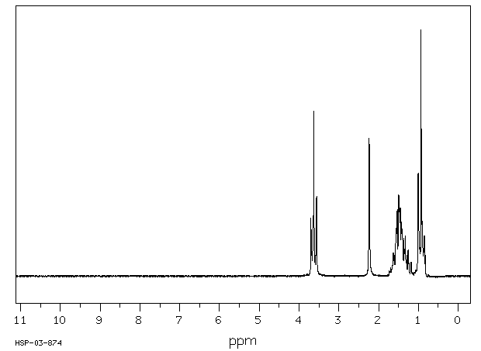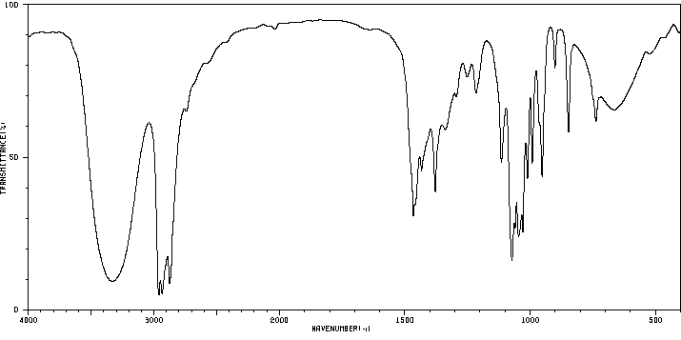 IR Spectra (thin film (neat) on KBr Disc) ¹H-NMR Spectra (at 90 MHz in CDCl₃)
Infrared Spectra (thin film (neat) on KBr disc): ¹H-NMR Integration Data: (at 90 MHz in CDCl₃)
Spectrum Region | Absorp'n  Band # | Frequency  (cm⁻¹) | Peak Shape  (sharp, broad) | Peak Intensity  (strong, med. or weak) | Functional Group  Indicated | Signal # | Shift | Integrat'n | Splitting | Comment | #Neigh-bouring H | Signal Assignment
 |  |  |  |  |  | 1 | δ 0.9 | 3H
 |  |  |  |  |  | 2 | δ 1.4 | 4H
 |  |  |  |  |  | 3 | δ 2.2 | 1H |  | xchanges with D₂O
 |  |  |  |  |  | 4 | δ 3.6 | 2H
Structure Assigned to Unknown 360-14-11
Compound Name:

Unknown # 360-14-12
Mol. Wt. = 136.12 g/mol Chemical Formula = C₈H₈O₂ Degrees of Unsaturation = ___________________________________
b.p. = 230°C
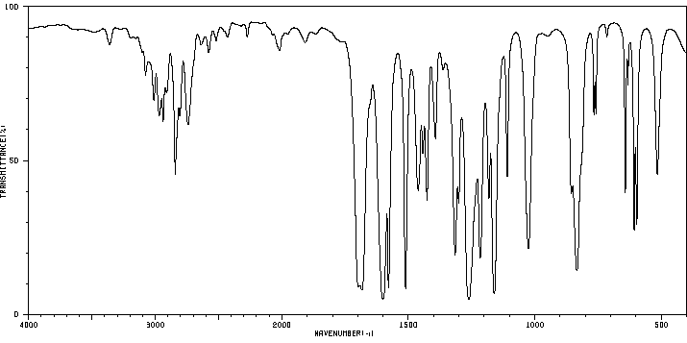IR Spectra (liquid film (neat) on KBr Disc) ¹H-NMR Spectra (at 400 MHz in CDCl₃)

Infrared Spectra (neat liquid film on KBr disc): 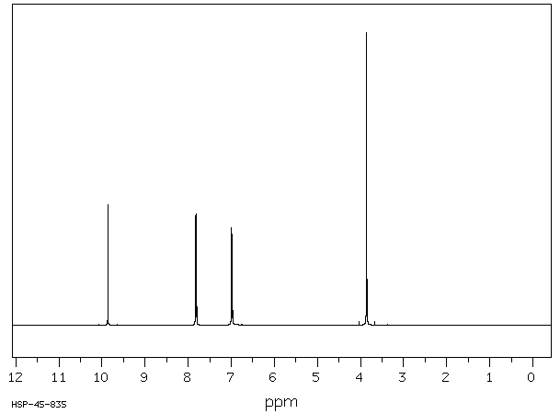¹H-NMR Integration Data: (at 400 MHz in CDCl₃)
Spectrum Region | Absorp'n  Band# | Frequency  (cm⁻¹) | Peak Shape  (sharp, broad) | Peak Intensity  (strong, med. or weak) | Functional Group  Indicated | Signal # | Shift | Integrat'n | Splitting | Comment | #Neigh-bouring H | Signal Assignment
 |  |  |  |  |  | 1 | δ 3.86 | 3H
 |  |  |  |  |  | 2 | δ 6.98 | 2H
 |  |  |  |  |  | 3 | δ 7.82 | 2H
 |  |  |  |  |  | 4 | δ 9.86 | 1H
Structure Assigned to Unknown 360-14-12
Compound Name:

Unknown # 360-14-13
Mol. Wt. = 184.02 g/mol Chemical Formula = C₄H₉I Degrees of Unsaturation = ___________________________________
b.p. = 130.5°C
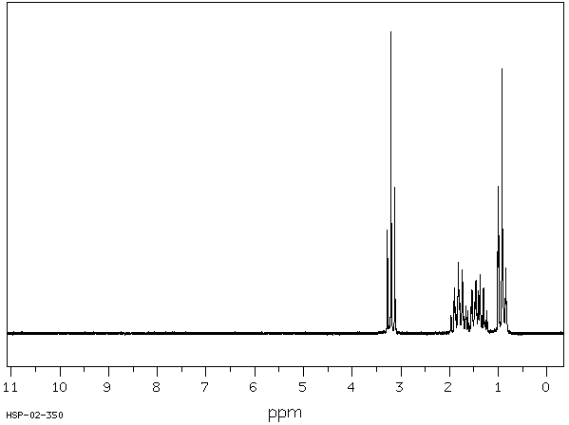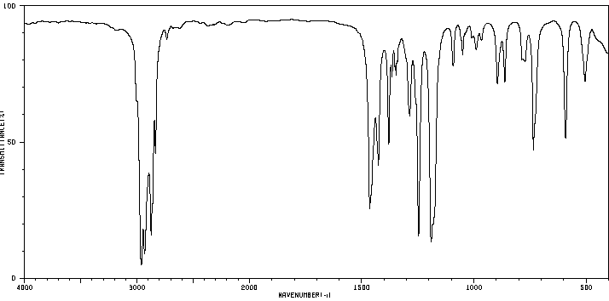IR Spectra (liquid film (neat) on KBr Disc) ¹H-NMR Spectra (at 90 MHz in CDCl₃)

Infrared Spectra (neat liquid film on KBr disc): ¹H-NMR Integration Data: (at 90 MHz in CDCl₃)
Spectrum Region | Absorp'n  Band# | Frequency  (cm⁻¹) | Peak Shape  (sharp, broad) | Peak Intensity  (strong, med. or weak) | Functional Group  Indicated | Signal # | Shift | Integrat'n | Splitting | Comment | #Neigh-bouring H | Signal Assignment
 |  |  |  |  |  | 1 | δ 0.9 | 3H
 |  |  |  |  |  | 2 | δ 1.4 | 2H
 |  |  |  |  |  | 3 | δ 1.8 | 2H
 |  |  |  |  |  | 4 | δ 3.2 | 2H
Structure Assigned to Unknown 360-14-13
Compound Name:

Unknown # 360-14-14
Mol. Wt. = 120.20 g/mol Chemical Formula = C₉H₁₂ Degrees of Unsaturation = ___________________________________
b.p. = 152.4°C
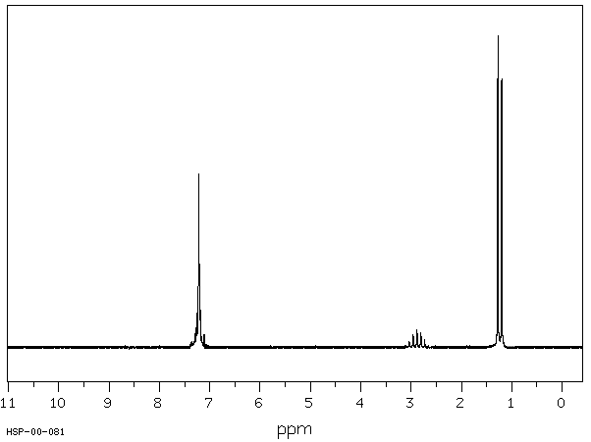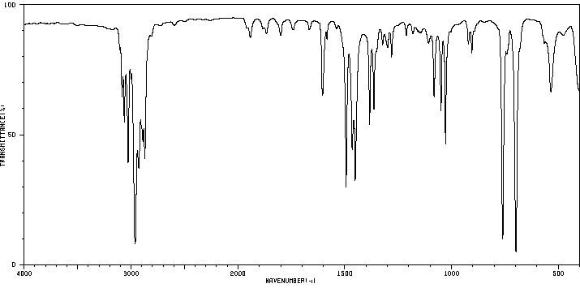IR Spectra (liquid film (neat) on KBr Disc) ¹H-NMR Spectra (at 90 MHz in CDCl₃)

Infrared Spectra (neat liquid film on KBr disc): ¹H-NMR Integration Data: (at 90 MHz in CDCl₃)
Spectrum Region | Absorp'n  Band# | Frequency  (cm⁻¹) | Peak Shape  (sharp, broad) | Peak Intensity  (strong, med. or weak) | Functional Group  Indicated | Signal # | Shift | Integrat'n | Splitting | Comment | #Neigh-bouring H | Signal Assignment
 |  |  |  |  |  | 1 | δ 1.2 | 6H
 |  |  |  |  |  | 2 | δ 2.9 | 1H
 |  |  |  |  |  | 3 | δ7-7.4 | 5H
Structure Assigned to Unknown 360-14-14
Compound Name:

Unknown # 360-14-15
Mol. Wt. = 88.12 g/mol Chemical Formula = C₄H₈O₂ Degrees of Unsaturation = ___________________________________
b.p. = 79.9°C
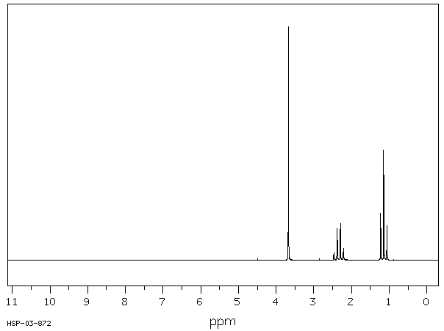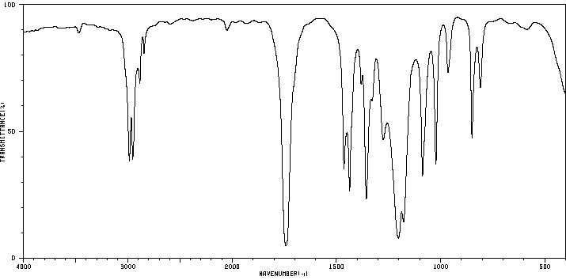 IR Spectra (liquid film (neat) on KBr Disc) ¹H-NMR Spectra (at 90 MHz in CDCl₃)

Infrared Spectra (neat liquid film on KBr disc): ¹H-NMR Integration Data: (at 90 MHz in CDCl₃)
Spectrum Region | Absorp'n  Band# | Frequency  (cm⁻¹) | Peak Shape  (sharp, broad) | Peak Intensity  (strong, med. or weak) | Functional Group  Indicated | Signal # | Shift | Integrat'n | Splitting | Comment | #Neigh-bouring H | Signal Assignment
 |  |  |  |  |  | 1 | δ 1.15 | 3H
 |  |  |  |  |  | 2 | δ 2.3 | 2H
 |  |  |  |  |  | 3 | δ 3.7 | 3H
Structure Assigned to Unknown 360-14-15
Compound Name:

Unknown # 360-14-16
Mol. Wt. = 124.14 g/mol Chemical Formula = C₇H₈O₂ Degrees of Unsaturation = ___________________________________
m.p. = 55-57°C
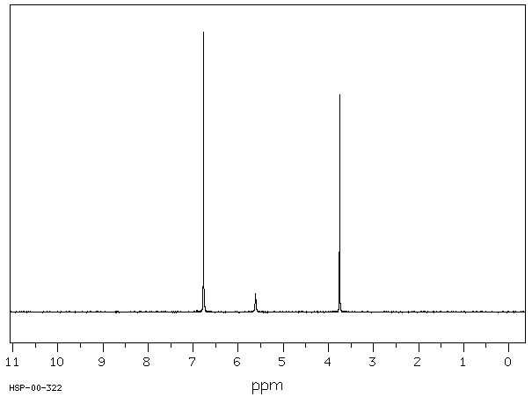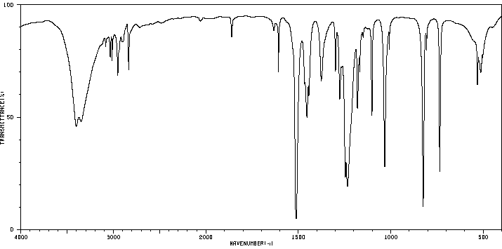 IR Spectra (on KBr Disc) ¹H-NMR Spectra (at 90 MHz in CDCl₃)

Infrared Spectra (on KBr disc): ¹H-NMR Integration Data: (at 90 MHz in CDCl₃)
Spectrum Region | Absorp'n  Band# | Frequency  (cm⁻¹) | Peak Shape  (sharp, broad) | Peak Intensity  (strong, med. or weak) | Functional Group  Indicated | Signal # | Shift | Integrat'n | Splitting | Comment | #Neigh-bouring H | Signal Assignment
 |  |  |  |  |  | 1 | δ 3.75 | 3H
 |  |  |  |  |  | 2 | δ 5.6 | 1H |  | xchanges  With D₂O
 |  |  |  |  |  | 3 | δ 6.8 | 4H
Structure Assigned to Unknown 360-14-16
Compound Name:

Unknown # 360-14-17
Mol. Wt. = 74.12 g/mol Chemical Formula = C₄H₁₀O Degrees of Unsaturation = ___________________________________
b.p. = 99.5°C
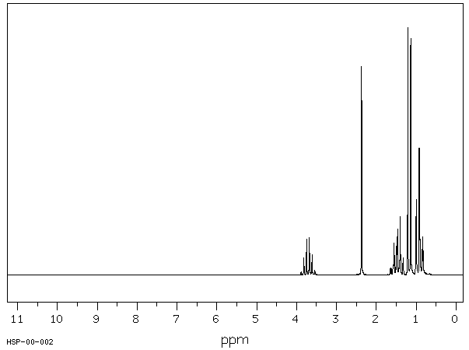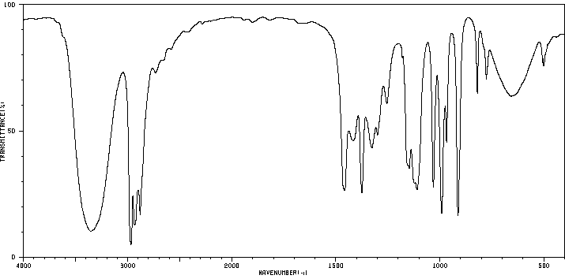 IR Spectra (liquid film (neat) on KBr Disc) ¹H-NMR Spectra (at 90 MHz in CDCl₃)
Infrared Spectra (neat liquid film on KBr disc): ¹H-NMR Integration Data: (at 90 MHz in CDCl₃)
Spectrum Region | Absorp'n  Band # | Frequency  (cm⁻¹) | Peak Shape  (sharp, broad) | Peak Intensity  (strong, med. or weak) | Functional Group  Indicated | Signal # | Shift | Integrat'n | Splitting | Comment | #Neigh-bouring H | Signal Assignment
 |  |  |  |  |  | 1 | δ 0.9 | 3H
 |  |  |  |  |  | 2 | δ 1.2 | 3H
 |  |  |  |  |  | 3 | δ 1.5 | 2H
 |  |  |  |  |  | 4 | δ 2.4 | 1H |  | xchanges  With D₂O
 |  |  |  |  |  | 5 | δ 3.7 | 1H
Structure Assigned to Unknown 360-14-17
Compound Name:

Unknown # 360-14-18
Mol. Wt. = 166.18 g/mol Chemical Formula = C₉H₁₀O₃ Degrees of Unsaturation = ___________________________________
m.p. = 20.7°C
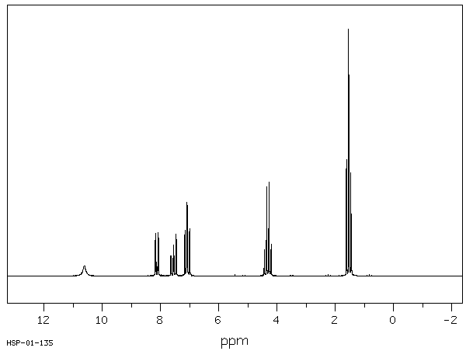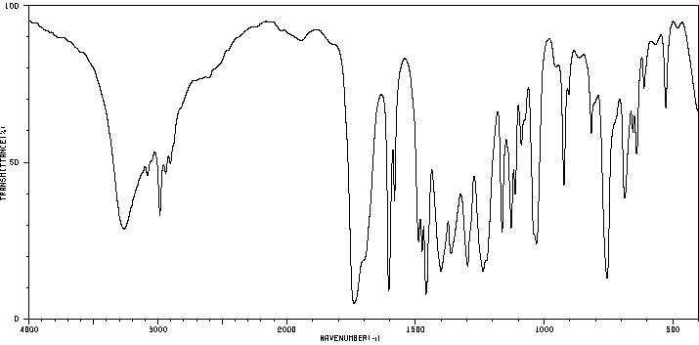 IR Spectra (on KBr Disc) ¹H-NMR Spectra (at 90 MHz in CDCl₃)
Infrared Spectra (on KBr disc): ¹H-NMR Integration Data: (at 90 MHz in CDCl₃)
Spectrum Region | Absorp'n  Band # | Frequency  (cm⁻¹) | Peak Shape  (sharp, broad) | Peak Intensity  (strong, med. or weak) | Functional Group  Indicated | Signal # | Shift | Integrat'n | Splitting | Comment | #Neigh-bouring H | Signal Assignment
 |  |  |  |  |  | 1 | δ 1.54 | 3H
 |  |  |  |  |  | 2 | δ 4.32 | 2H
 |  |  |  |  |  | 3 | δ 7.05  &7.1 | 2H |  | Hint: ortho substituion pattern
 |  |  |  |  |  | 4 | δ 7.5  &8.1 | 2H |  | Hint: ortho substituion pattern
 |  |  |  |  |  | 5 | δ 10.6 | 1H |  | xchanges  with D₂O
Structure Assigned to Unknown 360-14-18
Compound Name:

Unknown # 360-14-19
Mol. Wt. = 59.11 g/mol Chemical Formula = C₃H₉N Degrees of Unsaturation = ___________________________________
b.p. = 47.8°C
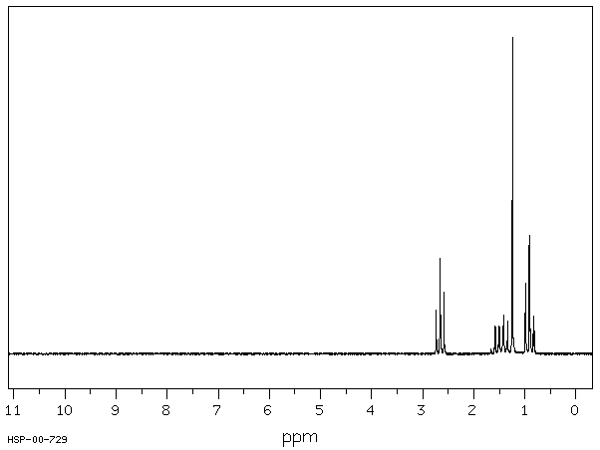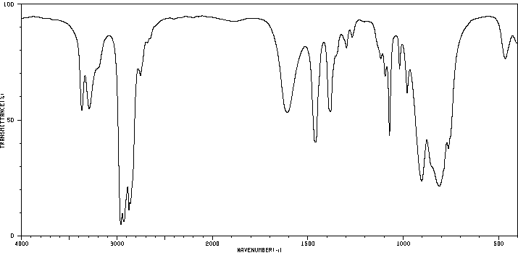 IR Spectra (liquid film on KBr Disc) ¹H-NMR Spectra (at 90 MHz in CDCl₃)
Infrared Spectra (liquid film on KBr disc): ¹H-NMR Integration Data: (at 90 MHz in CDCl₃)
Spectrum Region | Absorp'n  Band # | Frequency  (cm⁻¹) | Peak Shape  (sharp, broad) | Peak Intensity  (strong, med. or weak) | Functional Group  Indicated | Signal # | Shift | Integrat'n | Splitting | Comment | #Neigh-bouring H | Signal Assignment
 |  |  |  |  |  | 1 | δ 0.92 | 3H
 |  |  |  |  |  | 2 | δ 1.24 | 2H |  | xchanges with D₂O
 |  |  |  |  |  | 3 | δ 1.45 | 2H
 |  |  |  |  |  | 4 | δ 2.65 | 2H
Structure Assigned to Unknown 360-14-19
Compound Name:

Unknown # 360-14-20
Mol. Wt. = 107.16 g/mol Chemical Formula = C₇H₉N Degrees of Unsaturation = ___________________________________
b.p. = 200.5°C
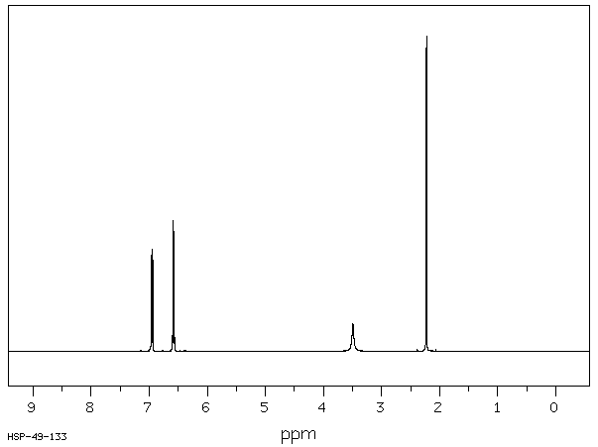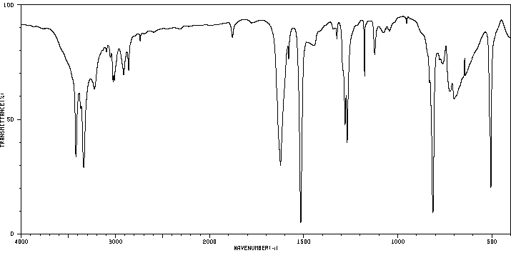 IR Spectra (on KBr Disc) ¹H-NMR Spectra (at 400 MHz in CDCl₃)
Infrared Spectra (on KBr disc): ¹H-NMR Integration Data: (at 400 MHz in CDCl₃)
Spectrum Region | Absorp'n  Band # | Frequency  (cm⁻¹) | Peak Shape  (sharp, broad) | Peak Intensity  (strong, med. or weak) | Functional Group  Indicated | Signal # | Shift | Integrat'n | Splitting | Comment | #Neigh-bouring H | Signal Assignment
 |  |  |  |  |  | 1 | δ 2.2 | 3H
 |  |  |  |  |  | 2 | δ 3.5 | 2H |  | xchanges with D₂O
 |  |  |  |  |  | 3 | δ 6.6 | 2H
 |  |  |  |  |  | 4 | δ 6.95 | 2H
Structure Assigned to Unknown 360-14-20
Compound Name:

Unknown # 360-14-21
Mol. Wt. = 138.2 g/mol Chemical Formula = C₈H₁₀O₂ Degrees of Unsaturation = ___________________________________
b.p. = unknown °C
IR Spectra (thin film on KBr disc) ¹H-NMR Spectra (at 400 MHz in 0.029 g in 0.5 mLCDCl₃)
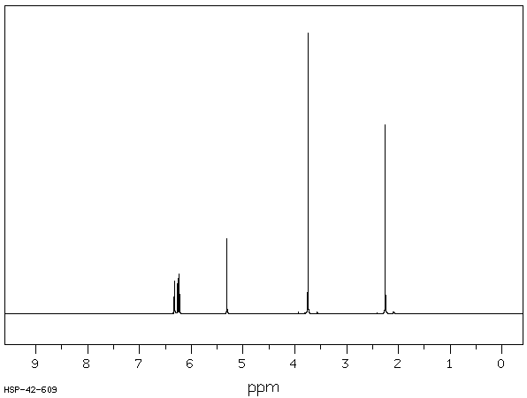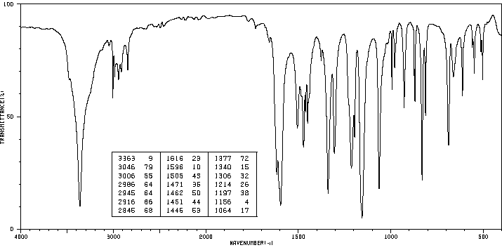

Infrared Spectra (on KBr disc): ¹H-NMR Integration Data: (at 400 MHz in CDCl₃)
Spectrum Region | Absorp'n  Band # | Frequency  (cm⁻¹) | Peak Shape  (sharp, broad) | Peak Intensity  (strong, med. or weak) | Functional Group  Indicated | Signal # | Shift | Integrat'n | Splitting | Comment | #Neigh-bouring H | Signal Assignment
 |  |  |  |  |  | 1 | δ 2.25 | 3H
 |  |  |  |  |  | 2 | δ 3.75 | 3H
 |  |  |  |  |  | 3 | δ 5.31 | 1H
 |  |  |  |  |  | 4 | 6.2 | 3H | multiplet
Structure Assigned to Unknown 360-14-21
Compound Name:

Unknown # 360-14-22
Mol. Wt. = 172.2 g/mol Chemical Formula = C₈H₁₂O₄ Degrees of Unsaturation = ___________________________________
m.p. = 1-2 °C
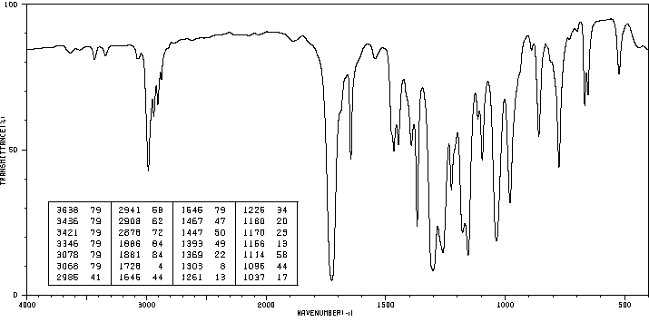 IR Spectra (liquid) ¹H-NMR Spectra (at 300 MHz, 10.4 mol% CDCl₃)
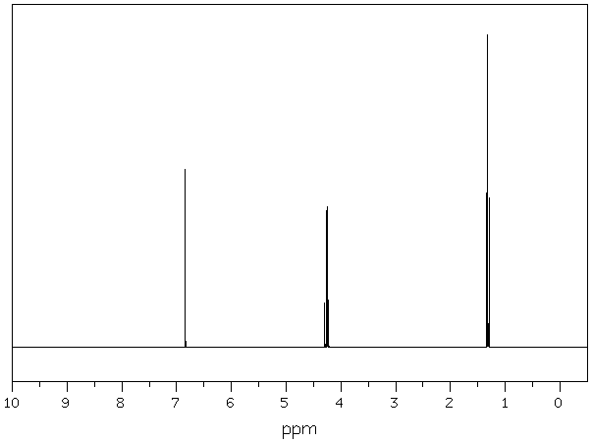

Infrared Spectra (liquid film): ¹H-NMR Integration Data: (at 300 MHz in CDCl₃)
Spectrum Region | Absorp'n  Band # | Frequency  (cm⁻¹) | Peak Shape  (sharp, broad) | Peak Intensity  (strong, med. or weak) | Functional Group  Indicated | Signal # | Shift | Integrat'n | Splitting | Comment | #Neigh-bouring H | Signal Assignment
 |  |  |  |  |  | 1 | δ 1.32 | 6H |  | 2 x 3H?
 |  |  |  |  |  | 2 | δ 4.26 | 4H |  | 2 x 2H?
 |  |  |  |  |  | 3 | δ 6.9 | 2H
Structure Assigned to Unknown 360-14-22
Compound Name:

